© 2014
Dudnikov Anatolij А., Candidate of Technical Sciences, Professor,
Bilovod Oleksander І., Candidate of Technical Sciences, Docent
Poltava State Agrarian Academy
Pasjuta Andrij H, director
State enterprise of research farm “9th Sichnya” in Khorolskyj district, Poltava region
Improving the reliability of working bodies of tillage machines
Reviewer – Doctor of Technical Sciences, Professor Horyk Oleksij V.
The article discusses issues of increasing longevity and reliability of working bodies of tillers in the process of recovery (manufacturing) using vibrations that promote intensification processing methods, increase the level of mechanization and automation of many labor-intensive technologies. The dependence of the intensity of the vibration to strengthen the following factors: the mode of processing, physical and mechanical properties of the material machined parts. Found that the main process parameters of the vibration of hardening is the disturbing force exciter, the amplitude and frequency of oscillation of the machining tool, the speed and processing time.
Keywords: reliability, wear rate, the manufacturing process, vibratory strengthening modes of deformation.

Problems Statement. Reducing public procurement has led to a dramatic reduction of acquisition of new equipment. In this connection, the machine-tractor fleet was reduced, and the load on the proper technique increased, which helped to reduce its durability due to increased wear and tear. Spare parts, repair entering production, are often discarded in the process of drawing up new machinery parts and assembly units. Installation of such parts in place of the worn not achieve resource new compound [3].
Restoration of details allows enterprises to reduce the residence time in the repair of machines, to improve the quality of maintenance and repair, which positively affects the improvement in the use of machines [5].
The economic aspect of the advisability remediation parts is to reduce the cost of repairs by reducing the cost of new replacement parts, as well as to reduce production costs in the operation.
To increase the reliability and durability of the working bodies of tillers significant role, according to the hero of Ukraine, Academician of agroecology S.S. Antonets belongs to their design [8]. Substantially increase the resources of agricultural machinery can be due to the use of hardening treatments working surfaces of parts [4].
Relevance of the topic due to the necessity of choosing an effective method of recovery wing shares cultivators by vibrating strengthening, as well as justification modes. Recovery from deformation vibration of parts remains relevant because it provides high quality and cost-effectiveness of the process.
Analysis of recent research and publications. In operation cultivators vary the size and shape of claws, which causes the change in the tractive resistance, which depends on the physic-mechanical properties of the soil, the working depth and speed of the unit [2].
Character wear claw is primarily dependent on the humidity of the soil at a depth of cultivation that during season changes much more than the depth of plowing, and which decrease the upper bound of the cutting edge wears activities [7].
The nature and amount of wear of the clutches influences the stability cultivator depth processing. Of education in the process of the occipital chamfer occurs deepening claws cultivator.
The wear limit on the width of the clutches comes after overlapping footprint claw of the first row of the second row to fall to 10-15 mm and cutting weeds exacerbated by relatively minor way to slip them over the blade roots.
The intensity of wear tines so great that in some cases there is a need for repairs after 2 ... 3:00 his work.
The quality of soil treatment significantly affected the state of the toe of the blade and tiller tines, performance are determined by the size of their sharpness and wear. Therefore, when restoring tines necessary to achieve high hardness and wear resistance of the sock and the blade feet, which will increase their durability.
Research of the interaction with the surface of the abrasive working body showed that for increased durability necessary to increase the abrasive wear resistance.
Determine the effectiveness in improving the durability of new and remanufactured parts reached abroad. Thus, in Germany Research Center (city Sharlottental) develops new technologies for the rehabilitation of worn parts by welding, plating, plastic deformation of the polymer materials.
In Poland, the recovery processes developed parts of the Scientific and Technical Service Center for Agriculture (city Lodz).
On one of the major enterprises of "Caterpillar" (USA) established a specialized area for recovery surfacing undercarriage crawler tractors.
In the case of recovery of claws cultivators usually apply the following methods: guy, cut claws worn portion of the blade of flame cutter followed by leaning profiled steel plate 65G. However, these methods have a high complexity and make it impossible to obtain a high durability.
There are studies on the restoration of the working bodies of tillers hard facing flux-cored wire and freezing of the welding on the work piece [1].
To increase the durability of the working bodies sometimes use magneto electric way of strengthening.
It should be noted that, despite the importance of the issue of restoration and strengthening of the working bodies of cultivators, effective means of improving the wear resistance is not completely justified and in repair production is insufficient or is not used.
The purpose and objectives of research. Purpose is to increase durability wing shares cultivators by vibrating strengthening during their recovery.
The objectives of the research are:
- to investigate the effect of processing on the nature of the vibration strengthening;
- to determine the optimal parameters of the vibration deformation;
- to assess the durability of restored tines and process vibrating strengthening.
Research methods and techniques. The research methodology was to theoretical and experimental approach recovery method tines, its main technological parameters. Theoretical studies based on the use of mathematical analysis. Experimental studies were carried out using the methods of mathematical statistics and multivariate methods of experiment.
The research results. Based on the analysis of the publications to improve the durability of the clutches of cultivators identified the following research areas: Develop efficient processes restore worn surfaces of the cutting elements tines; - Increased durability wing shares cultivators by the method of vibrating strengthening. One important factor in the application of technological process of restoration of those parts is a selection of their treatment options; determine the amount of wear of the cutting elements. Precise measurements of the thickness of the cutting edge tines implemented MCC-25 micrometer with digital reading device to an accuracy of 0.001 mm (SOST 6507-90), and measurement of the main angles claw produces digital protractor to an accuracy of 5 '. Geometric parameters were measured with a caliper claws SHTSTS-500 with a readability of 0.01 mm. Statistical processing of the data was performed using Microsoft Excel. Studies on strengthening clutches by vibratory strain were made on our setup (Fig. 1), thereby strengthening the surfaces of various parts with the necessary processing parameters: the disturbing force, the amplitude and frequency of oscillation of the machining tool, the speed of its movement.
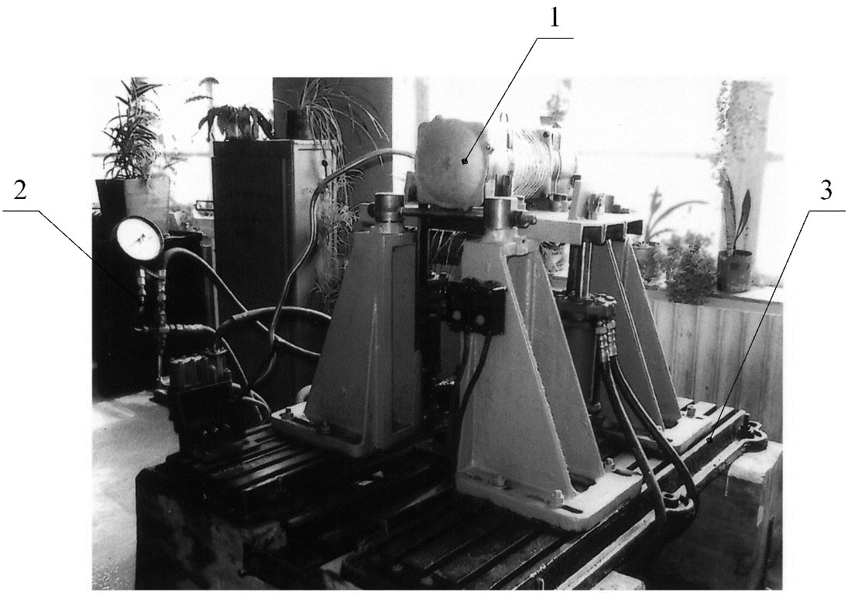
Fig. 1. General view of the vibration machine: 1 – exciter of vibration; 2 - the hydraulic system; 3 - basics with additional accessories

Scheme of the vibratory apparatus is shown in Fig. 2
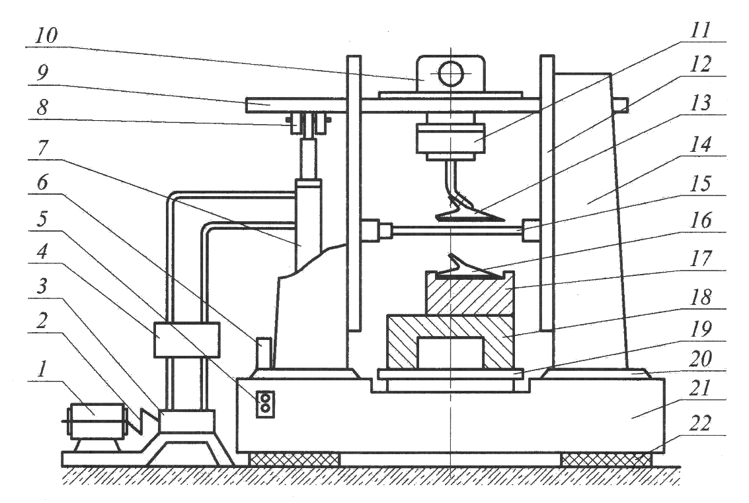
Fig. 2. scheme of vibration machine: 1 - 2 motor - clutch, 3 - hydraulic pump; 4 - distributor; 5 - starter; 6 - a tank; 7 - the hydraulic cylinder; 8 - rubber shock absorbers; 9 - plate vibrator; 10 - a vibrator; 11 - the clamping device; 12 - directing; 13 - Tools; 14 - Front; 15 - screed; 16 - matrix; -Items 17; 18 - base; 19 - cooker; 20 - base plate; 21 - timber; 22 - Shock Absorber

Indicating cultivator lancet claws during operation are subjected to abrasion, which leads to downsizing and blunting of the blade that causes a decrease in efficiency of working bodies.
In the process of strengthening parts vibratory deformation plastic deformation of the surface layer of the material changes its physical and mechanical properties, which is largely due to the increasing strain as the shear resistance of dislocations [6].
For the vibration angle of intersection of lines sliding treated surface ranges from 45 ° to 90 °. Thus, at the instant the machining tool machining forces will be directed at a large angle to the direction of its movement, i.e. force, the degree of compaction and the deformation amount in the radial direction will have greater value than normal deformation.
The degree of hardening of the material being processed can be determined:
$η=\frac{F_{0}}{F_{1}}$, (1)
where F₀ and F₁ – surface to be treated before and after deformation.
Calculated values of the degree of hardening of the surface material are shown in Table 1.
Table 1. The value of hardening degree
processed material | value η
processed material | usual  deformation | vibratory  deformation
1. Steel 65H | 0,037 | 0,0,54
2. Steel L-53 | 0,040 | 0,059
3. Steel 65H, sormite | 0,032 | 0,044
4. Steel L-53, sormite | 0,035 | 0,058

Research has shown that the degree of hardening of steel samples 65H, followed by welding and vibration strengthening sormite 1.38 times greater than with conventional treatment.
For experimental verification of the theoretical presuppositions about the feasibility of using technology to strengthen the vibrating tines we were determined following their parameters (Fig. 3): width (b); distance from the first hole to the sock is length of the sock (a); the width of the wing at the end of the blade (c); the thickness of the cutting edge at a distance of 2 mm (h).
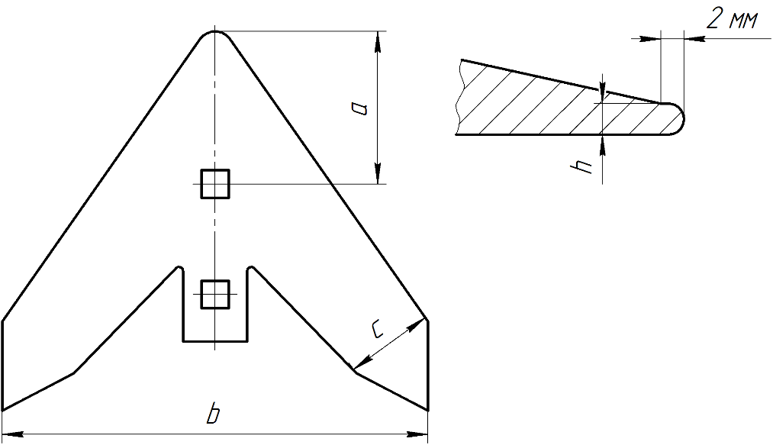
Fig. 3. Controlled claw size
Bench tests were conducted on eight legs following: new steel 65H; restored sling heated claws; restored arc submerged arc welding; restored arc welding and submerged arc vibrating strengthening.
Research has established that the wear of the sock new claws 1.54 ... 1.67 times greater than the width of the wing.
These measurement parameter (a) were as follows: for new claws – 42 ... 47 mm; restored sling heated claws – 50 ... 57 mm; restored welding sormite – 39 ... 41 mm; restored and vibration welding sormite strengthening – 34 ... 36 mm. Thus the magnitude of wear of the fourth version of the sock of the claw 2.14 ... 2.24 times lower compared to wear new cultivator claws.
One major reconstruction parameters tines working surfaces is the quantity of deformation is used to compensate their wear. Exploration samples were subjected to - claws thick blade of 0.5 mm, with an angle of the opening 2γ = 65 °, and the hardness of the cutting edge of the claw 48... 54 HRC.
Studies have shown that the variation width of the blade and the reduction of its thickness for a given value of the amplitude of the machining tool is identical. The greatest value of these quantities occurred at an amplitude of oscillation A = 0.5 mm, and the smallest is for A = 0.75 mm.
This character of the changes of these parameters can be explained by the fact that when the amplitude A = 0.25 mm appear insufficient quality of the vibrations of the machining tool. When the amplitude A = 0.75 mm, there is less contact with the tool surface to be treated more as a result of his separation. When this load on the material to be treated has a percussive character, it results in decreasing of ductility. Thus, according to the amplitude A = 0.5 mm increment value width of the blade claws of 1.12 times greater than at A = 0.25 mm and 1.37 is for A = 0.75 mm. Reducing the thickness of the blade claws respectively amounted to 1.21 and 1.42 times.
Results of the studies (Fig. 4) have showed that the curves of depreciation allocated two characteristic periods. The first test duration up to 30 minutes is characterized by increased the wear, and the second is a stable wear test samples. Dynamics of wear during this period has a character close to linear.
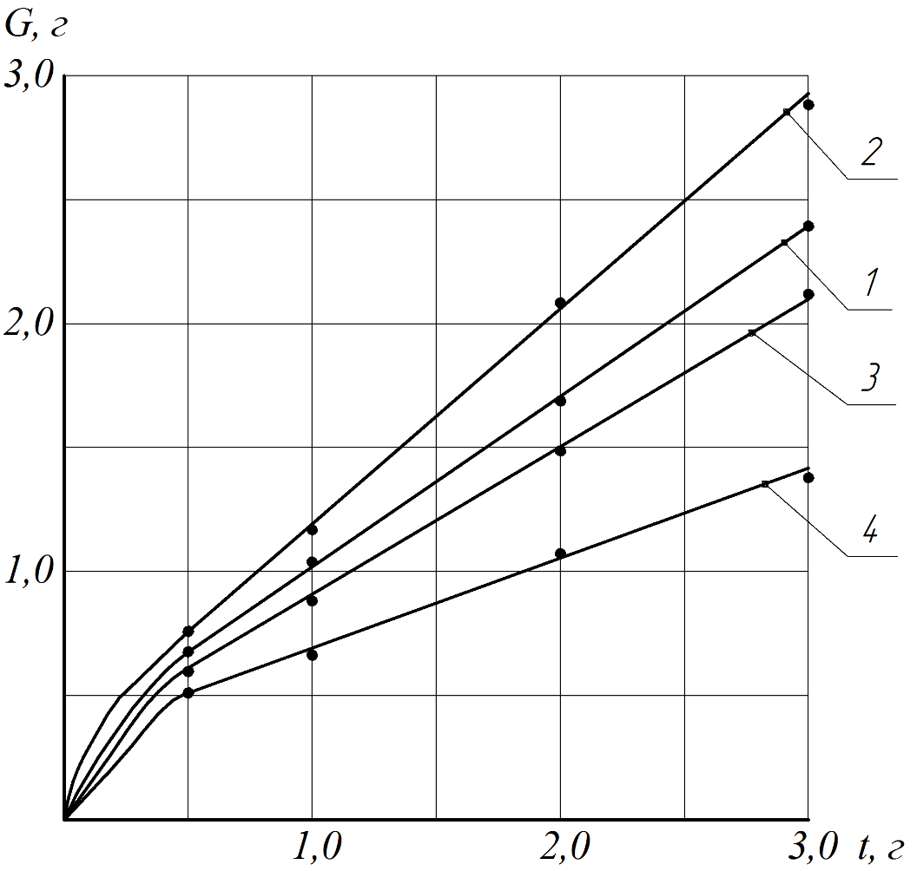
Fig. 4. Dependence of the wear patterns on the variant and the test time: 1 - new steel 65H; 2 - restored sling heated claws; 3 - restored arc welding under flux; 4 - restored arc welding and submerged arc deformation vibration

The most intensive wear samples recovered sling heated claws 2.8 g, and the highest wear resistance (1.4 g) in claws recovered arc welding and submerged arc reinforced vibration deformation, i.e. half.
On trial were put claws four options:
- new steel 65H;
- restored sling heated claws;
- restored arc submerged arc welding;
- restored arc submerged arc welding and hardening deformation vibration.
Performance tests are conducted in the experimental farm of the State Enterprise "9th Sichnya " Khorolskyj district, Poltava region on the cultivator KPS-4.
The data obtained in the performance tests allow using them for the development process operations in the process of restoring of the cultivator claws, and in their manufacture.

BIBLIOGRAPHY
1. Бетеня Г. Ф. Нанесение износостойких покрытий при упрочнении и восстановлении почворежущих элементов наплавкой намораживанием / Г. Ф. Бетеня, Н. В. Кардаш, Н. А. Зайко и др. // Защитные покрытия на металлы. – 1990. – Вып. 24. – С.94-97.
2. Войтюк Д. Г. Сільськогосподарські машини / Д. Г. Войтюк, Г. Р. Гаврилюк. – К. : Каравелла, 2004. – 552 с.
3. Дудніков А. А. Проектування технологічних процесів сервісних підприємств/ А. А. Дудніков, П. В. Писаренко, О. І. Біловод [та ін.]– Вінниця: Наукова Думка, 2011. – 400 с.
4. Проблема реалізації технічної політики в агропромисловому комплексі / за ред. Я. К. Білоуська. – К. : ННЦ «ІАЕ», 2007. – 215 с.
5. Рибак Т. І. Пошукове конструювання на базі оптимізації ресурсу мобільних сільськогосподарських машин / Т. І. Рибак. – Т. : ВАТ «ВПК», 2003. – 332 с.
6. Сторожев М. В. Теория обработки металлов давлением / М. В. Сторожев, Е. А. Попов. – М. : Машиностроение, 1997. – 423 с.
7. Ткачев В. Н. Износ и повышение долговечности деталей сельскохозяйственных машин / В. Н. Ткачев. – М. : Машиностроение, 1971. – 264 с.
8. Черкас В.М. Автограф на землі. Фоторозповідь про життя і творчість Семена Свиридоновича Антонця / В. Черкас. – Полтава : ТОВ «Симон», 2013. – 288с.

