© 2014
Kulinich S. N., Doctor of Veterinary Sciences
Poltava State Agrarian Academy
EFFICIENCY OF CRYOLYSIS AT SAT CATTLE DURING THE EXTRACTION
OF MALIGNANT NEOPLASMS ON EYELIDS
Reviewer is Zamaziy A., Doctor of Veterinary Science
The symptomatology of malignant neoplasms of eyelids sat cattle is found out. Tested method of cryolysis of malignant neoplasms of eyelids at sat cattle. Efficiency of the procedures in a postoperative period in the dynamics of clinical and morphological indexes of blood is defined. It is set by planimetric researches that till 15th day reduction of wounded defect of relatively initial indexes was 58,0%. At the 20th day scars were barely noticeable and was only 11,1% according the initial data.
Keywords: liquid nitrogen, malignant neoplasms, morphological studies of the blood.

Description of the problem. Cryosurgery (gr. kryos (cold) + surgery) is a set of surgical treatment methods based on local freezing of the tissues [5].
Doctors of veterinary medicine are pay sufficient attenti on methods of cryosurgery. There are only a few recommendations for its clinical application, especially in a comparative perspective with other methods of treatment, in domestic and foreign literature [1]. Meanwhile cryosurgical method has some advantages and therefore very promising for the treatment of cancer and therapeutic diseases [4].
Cryosurgery (or removal of neoplasms by liquid nitrogen) is one of the most common methods of treatment of tumors. This method is quite common, in many cases, it is indispensable, but it has several disadvantages. In particular during freezing the tissue with liquid nitrogen, the patient may experience some discomfort, a burning sensation or slight pain sensations which soon pass. After cauterization by nitrogen the plot becomes allocutio to external stimuls, there is a small swelling. Perhaps the appearance of small blisters on the burn during the day after cauterization by nitrogen.
There is a complete rejection of body tumors over the next few weeks. Inconspicuous spot (which disappears due to the full updated skin cells) remains on the place of cryosurgery.
Analysis of major studies and publications which discuss the problem. American physician Irving Cooper knowns as the Creator of the first cryosurgical instrument in medicine. His Christmas gift pushed to create this cryosurgical instrument – it was device which for opening wine bottles.
History has preserved even the date of this important moment - December 25, 1960. In the device “opener for wine” was used compressed carbon dioxide gas which is introduced through a needle to puncture the stopper of the bottle. The physician noted that the stream of gas output was very cold.
In addition he tried to direct a jet on the palm and got a strange result - hand was covered by ice crystals, and the effect of freezing had a local character. A similar principle was used in his invention. The working part of the instrument consisted of a thin tube through which flowed liquid nitrogen. This tool American physician used in neurosurgery, with operations to remove brain tumors. Thus, the authorship regarding the application of liquid nitrogen in operations on the brain for freezing belongs to the doctor Irving Cooper [6].
Liquid nitrogen for the treatment of pathological processes began used in veterinary medicine much later. In particular V. N. Vaitkus used it for the treatment of Tami in cattle, I. F. Velkovski used it in the treatment of dogs’ liver tumors [2; 3].
Objective: to determine the effectiveness of cryosurgery squamous cell carcinoma of the eyelids in cows.
Task: develop operative technique and determine the efficacy of the manipulation in the postoperative period.
Materials and methods. Our studies were conducted in the period 2012-2013. The cows owned by the residents of Poltava region were selected for experience. MalignanciesIn were diagnosed at animals with clinical examination who were after sedation and local anesthesia are removed followed by cryosurgery.
To calm the animals intravenously (jugular vein) was administered 1 ml of “Xela” (Interchemie Werken “de Adelaar” BV, The Netherlands). After sedation of the animals spent infiltration of tissues forever 0,5 % solution of novocaine at the animal spent 40-50 ml of solution.
The bulk of blastoma cut with scissors Cooper, then stopped the bleeding by applying large 15x12 cm sterile cotton-gauze wipes. Only after these procedures were cryosurgery tissues. Used the liquid nitrogen (boiling temperature of which was 196 ºС). It brought and kept in the Dewar vessel of
5 liters.
To the treatment site the substance were taken using long forceps which for 10-15 seconds immersed in an open vessel with liquid nitrogen for cooling. The cooled forceps pressed to the tumor up to the formation of white ice around the edges of the pad. First time liquid nitrogen was applied once and not more than 5 seconds, because maybe there is a heightened sensitivity to it. When performing cryosurgery first edge of the skin took 3 mm of healthy skin and cooled. When handling liquid nitrogen korting marked with borders, protecting the surrounding normal tissue from cold damage. Later in the freezing process involved in all the deeper tissues. The cryosurgery was performed for 15-20 minutes. Optionally ever put a makeshift stitches were removed after 7 days. In the postoperative period investigated the dynamics of clinical (every day until recovery planimetric research which was to measure the length with a ruler) and morphological parameters of blood (the first, tenth, fifteenth).
Statistical processing of results of experimental studies carried out by determining the arithmetic mean (M), its error (m), confidence level (p) using table t-student test. Change scores were considered significant at p<0.05.
The results of the study. During surgical examination we have selected a group of five cows have been diagnosed «squamous cell carcinoma of the right lower eyelid». At clinical examination have been found that in 100 % of cases of uruguaiana lower eyelid of the right eye and found that it had no metastases, however, had infiltrative growth.
Blastoma of the ever diagnosed as nodular seal or in two cases a flat warty education which hung above the skin surface and partially closed eye. On the surface of a tumor was discovered dark brown or black crust stuck to her hair and slices of straw. After it removal showed blastoma from ulcers with thick edges and uneven bottom. Tumor vrestal in the eyelid and partially destroying it. Due to irritation of the lower eyelid was observed tearing and purulent exudation. The size of the tumors was 11-13 cm long and 8-9 cm in width (picture 1a).
After removal of the tumors (picture 1b) in the postoperative period were observed reduction of wound defects. In particular we can say (by analyzing the obtained data) that on the third day the length of the wound (table. 1) decreased by 9,6 %. Accordingly on the seventh day the decrease amounted to 29,4 %, and on the tenth it was 35,8 %. Up to 15th day decreased was 58,0 % relative to the initial data. When conducting measurements at the 20th day the scars were barely noticeable and was only 11,1 % relative to the initial data.

Table 1. The dynamics of reducing the length of the wound defect during treatment (M±M)
Days | The length of the wound
Days | cm | %
First | 12,6±1,8 | 100
Third | 11,4±2,2 | 90,4
Seventh | 8,9±2,4 | 70,6
Tenth | 8,1±1,4 | 64,2
Fifteenth | 5,2±1,6 | 41,2
Twentieth | 1,4±1,6 | 11,1

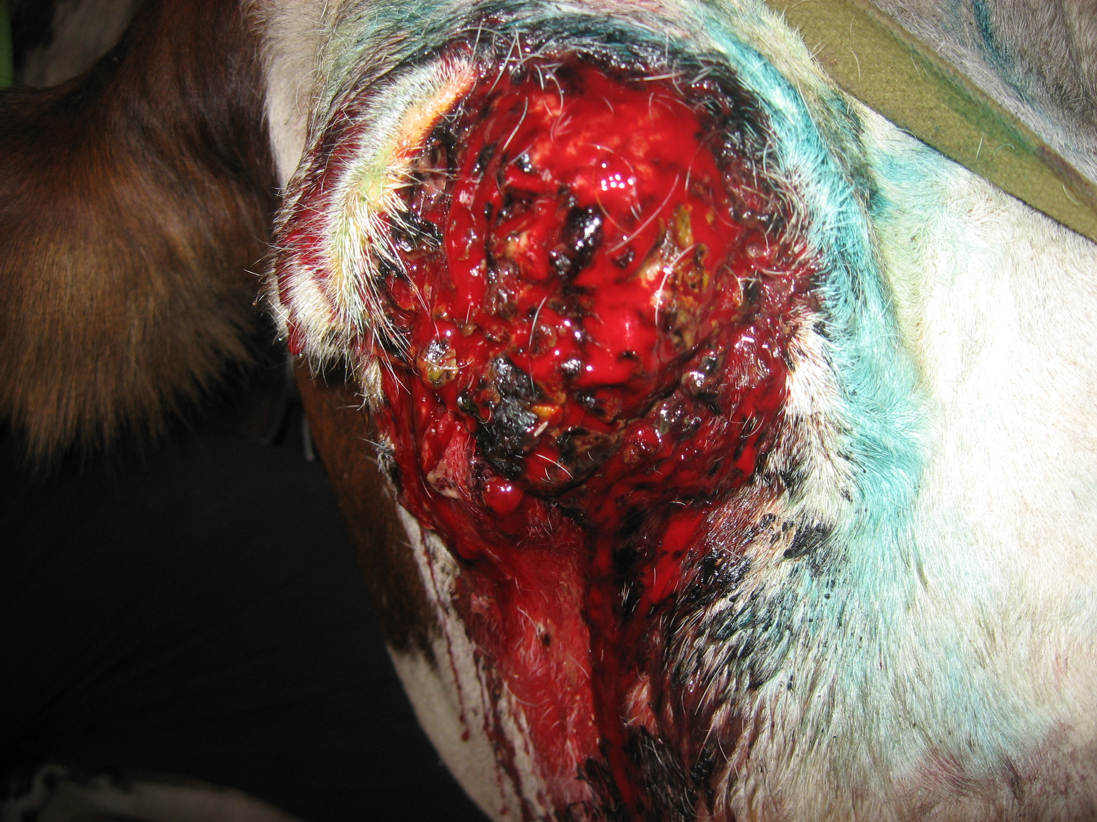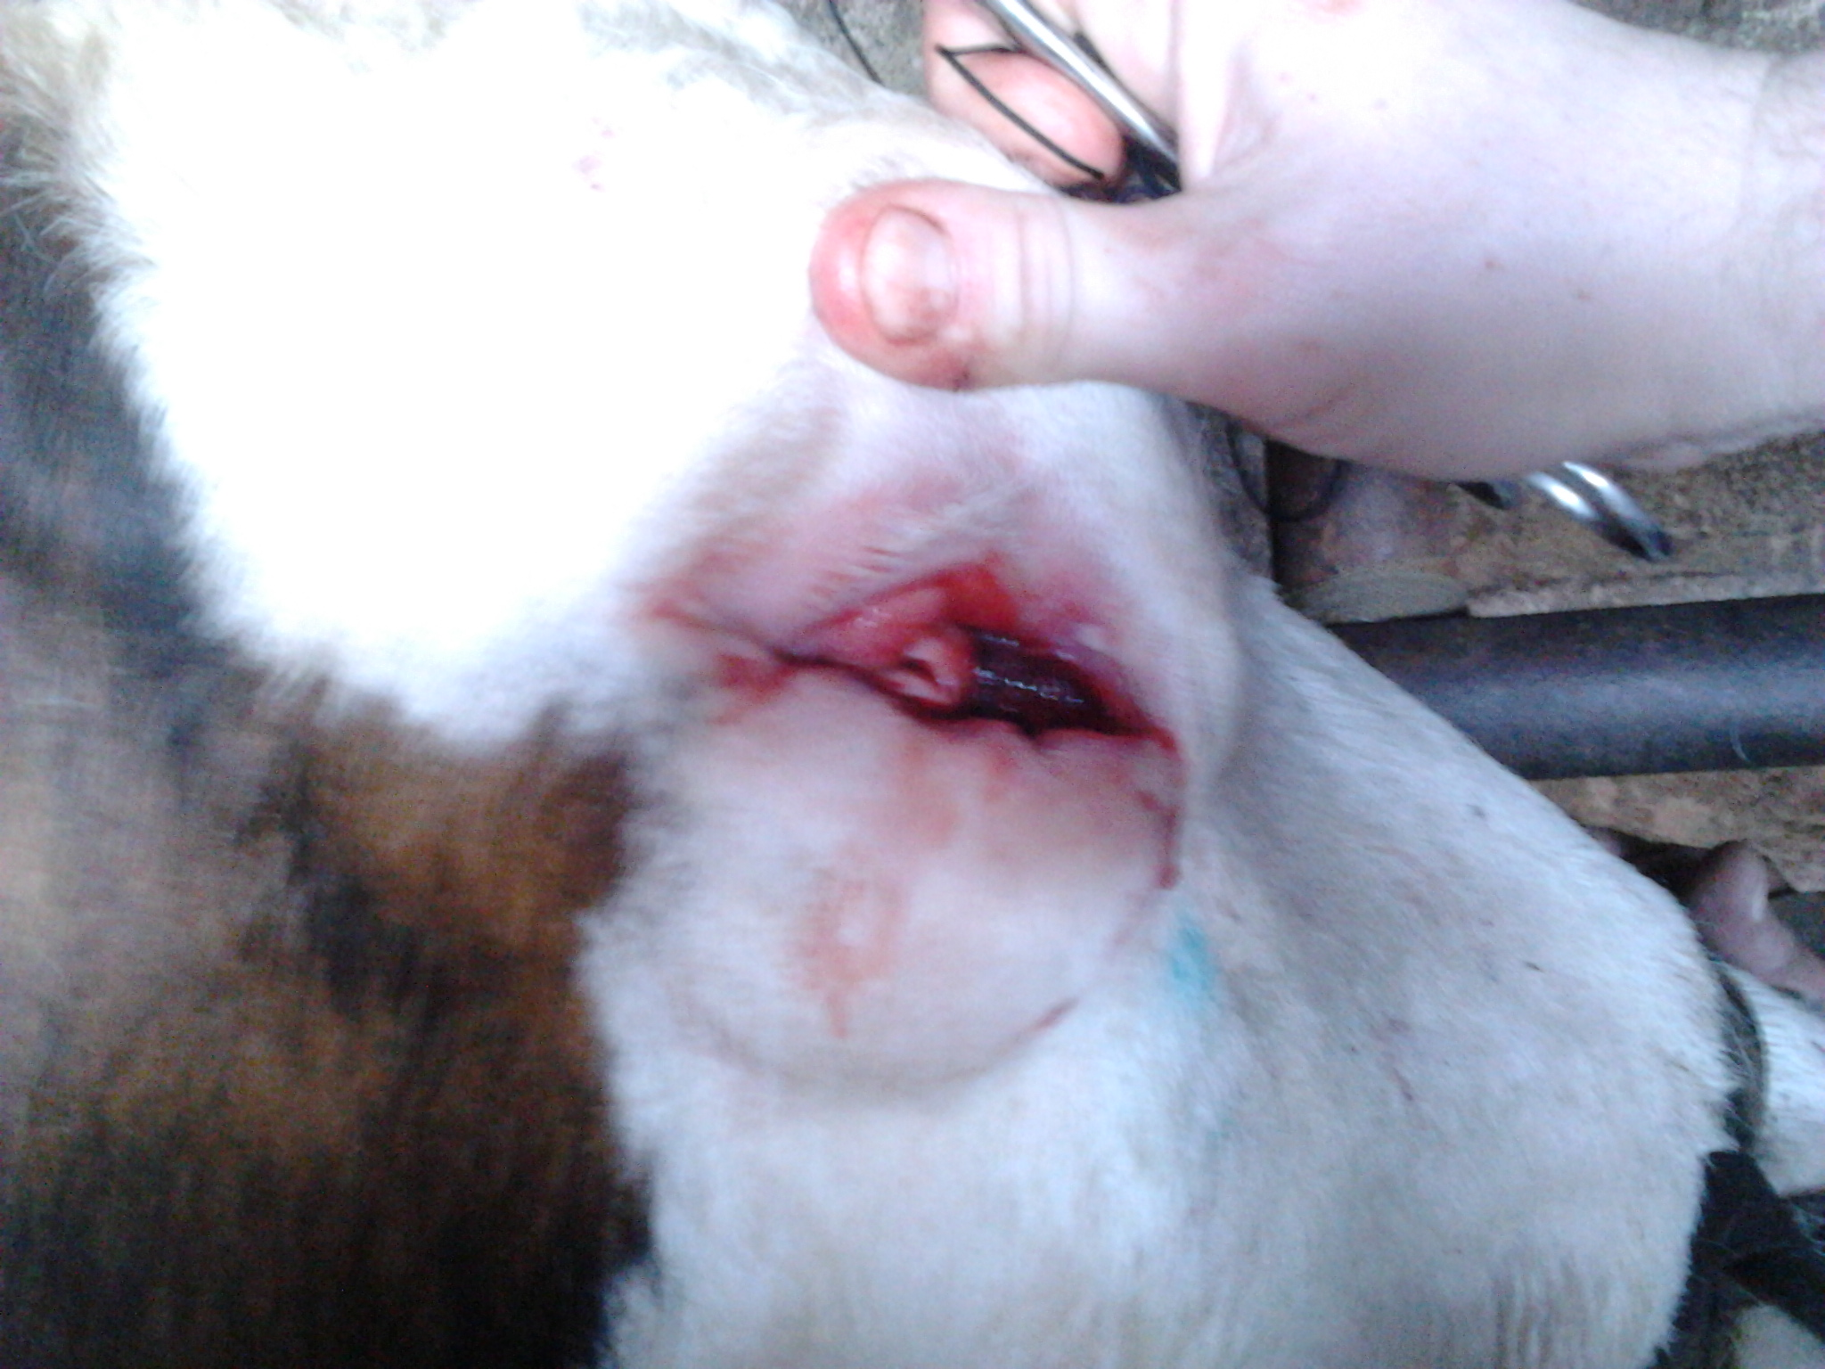
а б
Picture. 1. Research animal (pathological focus):
a) before removal of the tumor; b) after removal of the tumor

In connection with the tasks, we also conducted laboratory blood tests. After analyzing the data (table 2) we can state the following: after completing the cryoablation of tumors on the 10th day recorded an 8,6 % increase in the number of leukocytes. Up to fifteen day this trend is preserved, thus their number is close to the upper limit of normal, and was 12,5 % higher relative to the original data. Regarding the number of erythrocytes and hemoglobin should be noted that their performance did not change significantly until the end of the treatment period.

Table 2. Morphological composition of blood of the operated animals (M±m)
Indexes | Animals, n = 5
Indexes | resection of vein
Indexes | first day | 10th day | 15th day
leucocytes, G/l | 10,4±1,6 | 11,3±1,2 | 11,7±7,4
red corpuscles, T/l | 5,6±0,1 | 5,8±0,9 | 5,5±0,14
haemoglobin, г/л | 97,0±8,7 | 98,0±14,8 | 99,0±1,8

So, we conducted morphological analyses and it indicate that use of the method of cryoablation of tumors is accompanied by a tendency to increase the number of leukocytes.

Conclusions:
1. It is established that after first cooling in the first hours there is a pronounced inflammatory edema in the place of cryosurgery of the tumor and surrounding tissues. The section to the cryonecrosis after two days turns into a dry crust which is separated after 2,2±2,3 days.
2. Planimetrically studies have established that up to 15th day reduced the wound defect relative to baseline was 58,0 %, and on the 20th day the scars were barely noticeable and was only 11,1% relative to the initial data.
3. In cases of formation at cows squamous cell carcinoma of the eyelids which after surgical removal has relapse we recommend after sedation of the animal make infiltration of tissues eyelids by 0.5% solution of novocaine (40-50 ml solution), the bulk of blastoma cut with Cooper scissors and then cryosurgery tumors liquid nitrogen for 15-20 minutes.

BIBLIOGRAPHY
1. Борисевич В. Б. Методи оперативного втручання з використанням кріогенних технологій. Методичні рекомендації / [В. Б. Борисевич, В. П. Сухонос, П. К. Солонін та ін.]. – К., 2012. – 27 с.
2. Вайткус В. П. Применение жидкого азота при лечении тиломы у крупного рогатого скота / В. П. Вайткус, Б. А. Башкиров // Хирургические болезни сельскохозяйственных животных : cб. науч. тр. ЛВИ. – Ленинград, 1989. – С. 44–46.
3. Вилковыский И. Ф. Диагностика и лечение новообразований печени / И. Ф. Вилковыский // «Российский ветеринарный журнал. Мелкие домашние и дикие животные». – М. : Колос. – 2006. – №1. – С. 14–17.
4. Сенчук А. Я. Органосохраняющая криохирургия предопухолевых заболеваний матки : доклад на Первой Междунар. науч.-практ. конф. [«Криохирургия. Современные методы и инновационные технологии»]. – 2007.
5. Криохирургия для животных. Какой рождественский подарок подтолкнул доктора Ирвинга
Купера к изобретению? [Електронний ресурс]. – Режим доступу : http://www.newcentury.ru/joom/ index.php?option=com_content&view=article&id=65%3Avetcryo&atid=43%3Avetnewspol&Itemid=63&lang=ru_6. http://otvetin.ru/naukatchech/9941-kakoj-rozhdestvenskij-podarok-podtolknul-doktora. html

