© 2018
Zhukov O. V., Doctor of Biological Sciences
Dnipro National University named after Oles’ Honchar
Ponomarenko S. V., applicant
Poltava State Agrarian Academy
SPATIAL-TIME DYNAMICS OF CEREALS OF GRAIN AND GRAIN CROPS IN POLTAVA REGION
Reviewer – Doctor of Agricultural Sciences, Professor P. V. Pysarenko
The methodical approaches for determining the nature of the effect on the yield on the regional scale of factors of agroeconomic, agrotechnological and agroeconomic nature are elaborated in the work. It was shown that the yield of crops of cereals and legumes in agricultural enterprises of Poltava region by districts averaged over 1995–2016 ranged from 29.79±2.79 c/ha (Kobeliaky district) to 41.10±3.36 c/ha (Shyshaky district). The lowest level of variation of grain yield and leguminous crop yields during the study period was characteristic for Orzhytsia district (coefficient of variation 27,95 %), and the largest one for Chornukhy (CV = 62,02 %). The spatial component of variation in the average yield of grain and leguminous crops is insignificant. Significant contribution of factors of spatial nature in the variation of variability of crop yields is established. A clear trend has been established for increasing the yield of cereals and legumes during the study period, which can be described by linear dependence. The linear model coefficients are meaningfully interpreted as the rate of productivity growth over time and the productivity potential in the initial period of the study.
Key words: crop yield dynamics, trend, time series, spatial variability, agroecological factors.
Formulation of the problem. The dynamics of crop yields is defined as the result of aggregate agroecological, agroeconomic and agrotechnological factors. In the context of agroeconomic factors, one should point out the socio-economic crisis in Ukraine in the early 90's of the XX century. In the transition to market relations, conditions for free pricing were created for all sectors of the economy, and for the purpose of agriculture, oriental prices were introduced, which grew at a considerably lower rate than goods and services consumed by agriculture, which led to a price disparity not in favor of the agrarians. It, in turn, influenced the development of agriculture as a whole, and on the production of grain [6]. Among the agro-environmental factors are global climate change [11]. It necessitates the adaptation of domestic agriculture to such changes by developing new scientific approaches and economic substantiation of technologies for the cultivation of certain cereals that are in demand in the domestic and world markets [2]. Plant productivity, which directly affects the formation of economic indicators of grain production, also depends on certain soil-climatic conditions [1]. Therefore, the analysis of spatio-temporal dynamics of grain yield and legume crops in Poltava region and the determination of factors influencing it are an important scientific problem.
Analysis of literary sources on this problem. Agrotechnological factors are a function of agroeconomic. The direct dependence of grain crop productivity on the timely and effective carrying out of any agrotechnological reception is established. All receptions are important, especially in the best agronomic terms. By the terms of sowing, the varietal and seed factors, effective crop rotation, norms of mineral and organic fertilizers, methods of protecting plants from weeds, diseases and pests, providing technical means etc. are connected. All links in the technological chain must be closely interrelated [3]. The main directions of increasing the adaptability of grain crops production in modern conditions are: placement of crops in favorable soil-climatic conditions, the creation of adapted varieties and hybrids to the natural conditions of Ukraine, the transfer of the grain industry to post-industrial models of development, provision of the raw material base for the development of bioenergy, the creation of fodder bases for livestock breeding, organic production development, grain market structuring [6].
The general level of grain yield and leguminous crops and the degree of variation of this indicator depends on agroeconomic (in the broad sense of the concept) and agro-ecological factors [12]. The influence of these factors is subject to the limiting factor principle: the factor that is in deficit (or excess) is decisive. To study the dynamics of crop yields, correlation-regression modeling is used [12]. To describe the trend of grain yield and legume crop yield dynamics in Ukraine for the period 1913–2012, a polynomial model of the fourth order was used [6].
The application of post-industrial models of the development of the grain industry involves the development and implementation of: resource-saving bioadaptive technologies for growing crops, an integrated system of plant protection, methods for optimizing plant growth and development processes taking into account climate change and based on the principles of precision agriculture [6].
The spatial variation of agroeconomic and agroecological factors is of a different nature [10]. An important aspect of the variation is also the regular patterns of time productivity dynamics. Therefore, the study of the patterns of variation of yield in space and time can provide a suggestion of one or another hypothesis about the origin of sources of variation of productivity of agricultural crops [4, 5, 7].
The aim of the work is to develop methodological approaches to distinguish the nature of the effect on the yield on the regional scale of factors of agroeconomic, agrotechnological and agro-economic nature.
Materials and methods. The research is based on open information about the grain yield and leguminous crop yields on average in the administrative districts of Poltava region for the period 1995–2016. Relevant information is contained in the official annual publications «Agriculture of Poltava region» of the Main Department of Statistics in Poltava region (http:/www.pl.ukrstat.gov.ua/).
The time series of yields for each administrative region were broken down into two components: the trend and the rest of the trend. The global trend was explained by the help of the dependence of crop productivity on time. As an analytic form of the trend we chose between polynomials of different order. Prefered polynomials of a smaller order (simpler in their analytic form) and those with the most explanatory ability. Parameters of the linear model can be interpreted independently in such a way that it can be given obvious physical content. It allows the respective coefficients to be considered as independent variables and to investigate their behavior depending on other agroecological variables, or to study the features of their spatial variability.
The spatial regularity of variance in yield and trend parameters can be studied using I Moran statistics [9]. The calculations are made in the GeoDa program [13]. The geographic information system is built using ArcGIS 10.2. Statistical calculations are performed in Statistica 10.0.
Results and discussion. The average level and variation in yield can be interpreted differently as agroecological indicators. The average yield is a marker of the ecological potential of the region for the production of biomass of a particular culture. Variation in yields also indicates the stability of agro-ecological systems as a superposition of natural and agro-economic factors.
The analysis of the data shows that the yield of grain crops and legumes (in weight after harvest) in agricultural enterprises of Poltava region by regions on average in 1995–2016 ranged from 29.79±2.79 c/ha (Kobeliaky district) to 41.10±3.36 c/ha (Shyshaky district) (see table).
Productivity of grain and leguminous crops (in weight after processing) in agricultural enterprises of
Poltava region by regions (c/ha, 1995–2016)
№ | Area | Medium | Minimum | Maximum | Trust interval |  | CV, %
 |  |  |  |  | -95 % | +95 % | CV, %
1 | Velyka Bagachka | 38,43±3,65 | 20,10 | 74,80 | 20,10 | 74,80 | 44,53
2 | Gadiach | 36,74±4,39 | 17,10 | 70,47 | 17,10 | 84,00 | 55,98
3 | Globyno | 35,44±2,58 | 19,40 | 63,00 | 19,40 | 63,00 | 34,11
4 | Hrebinka | 32,89±3,23 | 17,70 | 74,50 | 17,70 | 74,50 | 51,23
5 | Dykan’ka | 33,21±2,58 | 18,50 | 53,90 | 18,50 | 53,90 | 36,39
6 | Zin’kiv | 33,74±3,01 | 17,00 | 63,30 | 17,00 | 63,30 | 41,84
7 | Karlivka | 35,96±3,09 | 19,70 | 65,70 | 19,70 | 65,70 | 40,31
8 | Kobeliaky | 29,79±2,79 | 14,50 | 58,60 | 14,50 | 58,60 | 35,75
9 | Kozel’shchyna | 30,57±2,96 | 13,40 | 71,09 | 13,40 | 59,50 | 39,65
10 | Kotel’va | 35,59±2,58 | 19,20 | 67,71 | 19,20 | 60,00 | 34,01
11 | Kremenchuk | 29,94±2,45 | 14,20 | 54,70 | 14,20 | 54,70 | 38,33
12 | Lokhvytsia | 37,40±4,44 | 19,00 | 78,70 | 19,00 | 78,70 | 55,63
13 | Lubny | 32,92±3,44 | 14,80 | 67,30 | 14,80 | 67,30 | 49,06
14 | Mashivka | 35,49±4,11 | 16,10 | 72,70 | 16,10 | 72,70 | 39,27
15 | Myrgorod | 40,60±3,96 | 18,90 | 73,10 | 18,90 | 73,10 | 45,79
16 | Novi Sanzhary | 35,76±4,06 | 15,90 | 76,50 | 15,90 | 76,50 | 42,99
17 | Orzhytsia | 36,21±2,16 | 19,59 | 62,90 | 24,90 | 62,90 | 27,95
18 | Pyriatyn | 35,11±3,46 | 18,50 | 69,70 | 18,50 | 69,70 | 46,20
19 | Poltava | 32,97±2,63 | 18,30 | 60,60 | 18,30 | 60,60 | 37,47
20 | Reshetylivka | 34,78±3,17 | 19,40 | 80,25 | 19,40 | 66,00 | 42,73
21 | Semenivka | 34,87±3,05 | 16,80 | 61,50 | 16,80 | 61,50 | 41,05
22 | Khorol | 33,97±2,77 | 18,00 | 71,00 | 18,00 | 71,00 | 38,25
23 | Chornukhy | 32,90±4,35 | 14,30 | 75,30 | 14,30 | 75,30 | 62,02
24 | Chutove | 30,92±2,43 | 17,40 | 53,40 | 17,40 | 53,40 | 36,86
25 | Shyshaky | 41,10±3,36 | 22,90 | 71,90 | 22,90 | 71,90 | 38,35
The minimum yield was established in Kozel’shchyna district in 2000, and the maximum in Gadiach district in 2013. During the research period, the range of variation in average yield was from 35.40 c/ha (Dikan’ka district) to 61.00 c/ha (Chornukhy district).
Fluctuations in the yield of investigated crops clearly reflect the coefficients of variation [12]. The lowest level of variation of grain yield and leguminous crop yields during the study period was characteristic for the Orzhytsia district (coefficient of variation 27,95 %), and the largest one for Chornukhy (CV = 62,02 %).
Geographically, areas with high and average levels of sunflower yields are concentrated in the south-east of the region – in Novi Sanzhary and Mashivka districts. Also comparatively high yields are characteristic for the central districts – Myrgorod, Shyshaky and Velyka Bagachka. Clusters with low average yields are formed in the south of the region (Kozel’shchyna, Kobeliaky and Kremenchug districts), in the east (Chutovo, Poltava and Dykan’ka districts) and in the west (Grebinka, Chornukhy and Lubny districts).
In terms of variability in the north, a clear cluster of regions with a high level of variation in yields of cereals and legumes has been formed. To this cluster should include Chornukhy, Lokhvytsia and Gadiach districts. For the east of the region are characterized by areas with low and average yield variation. These are Kotel’va, Chutovo, Poltava and Dykan’ka districts. For some areas in the west also characterized by a low level of variation in yield. These are Orzhytsia, Khorol and Globyno districts.
You can estimate the value of the spatial variation component using the Moran chart (Pic. 1).
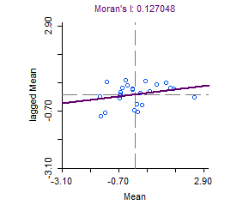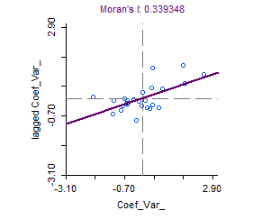
Pic. 1. Moran diagram for average grain and legume crop yield and coefficient of variation of this indicator
Spacing weights are chosen for the queen-like model. For the average yield, the statistics of I-Moran was 0.13. After 999 randomizations, the p-level difference from the random alternative was 0.08. Thus, the spatial component of the variation in the average yield of grain and leguminous crops is negligible. For the coefficient of yield variation, the I-Moran statistics was 0.34, and the p-level after randomization was 0.01, indicating a significant contribution of the factors of spatial nature in the variation of variability in crop yields.
Analysis of the dynamics of grain yields and leguminous crops in agricultural enterprises of Poltava region in time points to the existence of a clear trend of increasing crop yields during the research period. Adherence to the elements of the technology of growing crops, the main of which is plant nutrition and their protection from pests, diseases and weeds, have provided for this period increased yields of cereals and leguminous crops [6]. In some areas, the overall trend increase is monotonous (Velyka Bagachka, Globyno, Dykan’ka and some others) (Pic. 2A). In some areas, the majority of which, the period of growth is preceded by a decline in the mid-1990s (for example, Grebinka, Lokhvytsia, Poltava and some others) (Pic. 2B).
А
В
Pic. 2. Dynamics of grain yield and leguminous crop yields (in weight after processing) in agricultural enterprises of Poltava region by regions (c/ha, logarithmic data, 1995–2016)
Symbols: A – typical areas with a trend without a local minimum; B – typical areas with a trend with a local minimum
The presence of a general trend for growing crop and leguminous crops allows for the analytical description of dynamics in time to apply a linear model of the species:
Y = b x + a,
where Y is yield at time x, and a and b are coefficients. It should be noted that these coefficients can be interpreted comprehensively. Coefficient b can be interpreted as the rate of productivity growth over time, and a – as a potential yield in the initial period of the study. Note that the coefficients are calculated using the least squares method and all experimental data is included in the calculation. Thus, both the growth rate and the potential at the beginning of the observations are calculated to a certain extent in retrospect.
The presence of a local minimum and a deviation from the linear nature of the dependence of even logarithmic data makes the model of the second order of the form more correct:
Y = k • x2 + b • x + a,
where k • is the coefficient near the nonlinear term of the model x2. It is more difficult to interpret the corresponding coefficients. The sign of the coefficient k indicates the presence of a local maximum (negative coefficients) or a local minimum (positive value of the coefficient). The local minimum is usually observed in the investigated time range. While the local maximum goes beyond the time range investigated. It indicates that in this case the second-order equation may not be correct to describe the crop dependence on time, but another analytical form will be more acceptable. Also, the coefficient a indicates the value of the nonlinear component of the variation of the sign. If it approaches zero, then the equation is converted into a first-order equation.
The free member, like linear dependence, indicates the potential of crop yields at the beginning of the research period. Quantitatively, this ratio will be greater compared to the linear model in the case of a local minimum or less if there is a local maximum. In general, a nonlinear model is more accurately able to estimate this indicator.
Coefficient b indicates the linear component of the variation of the sign, and also the location of the local abscissa axis depends on it. But this provision also depends on the coefficient k. Thus, the analytic function is better performed by the linear dependence, and the descriptive one is a second-order polynomial.
The analysis of the spatial variation of the coefficient a of the linear model indicates that the smallest potential of yield at the beginning of the research period was noted for Chornukhy district and the districts close to it (Lokhvytsia, Lubny, Pyriatyn, Gadiach, Grebinka) (Pic. 3).

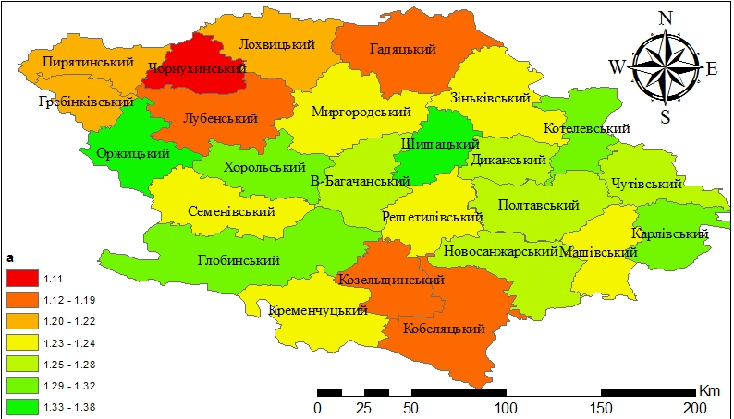
A
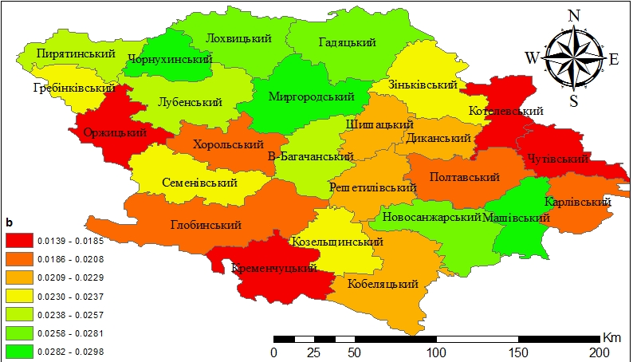
B
Pic. 3. Spatial variation of parameters of linear regression of the trend of crop yields of cereals and legumes for the period 1995–2016 A: coefficient a – yield potential at the beginning of the period, B: coefficient b – growth rate
Also, the small yield potential is characteristic for the southern regions – Kozel’shchyna and Kobeliaky. Areas with the greatest potential of grain yield and legumes during 1995–2016 are diffuse. In the west it is the Orzhytsia district, in the center – Shyshaky, in the east – Kotel’va and Karlivka district.
Between the coefficients a and b there is a statistically significant correlation relationship (r = -0.72, p = 0.00). It explains somewhat the fact that the map of the coefficient b is to some extent negative by the coefficient map a. Thus, the low potential of yield at the beginning of the study period in Chornukhy district was offset by a significant rate of productivity growth over the entire period. Accordingly, for the northern regions as a whole, high growth rates of grain yield and grain legumes during 1995–2016 are characteristic. On the contrary, in the east, west and south, low growth rates have been established for yields.
The determination coefficient indicates the compliance level of the observed data with the offered model. The remnant of the determination coefficient to the unit indicates the values ​​other than the overall linear trend, the reasons for the variation of the sign, or random causes (errors). The best results are given by a linear model for the central (Myrgorod, Velyka Bagachka) and south-eastern (Novi Sanzhary) districts (Pic. 4).
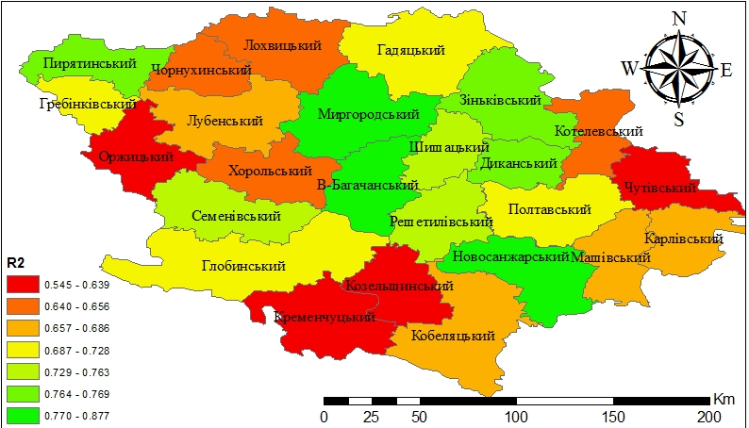R²
Pic. 4. Spatial variation of the coefficient of determination of linear regression of grain yield and leguminous crop yield trends during 1995–2016
The lowest values ​​of the determination coefficient are characteristic of the east (Chutovo district), the west (Orzhytsia district) and the southwest (Kremenchug and Kozel’shchyna districts).
Parameters of the linear model of the yield trend of grain and legume crops are characterized by the presence of a certain level of the spatial component of its variability. The I-Moran statistics for the coefficient a is 0.12. After the randomization procedure, the p-level probability of the difference from the random alternative of 0.08 is set. For the coefficient b, I-Moran statistics are 0.25 (p-level 0.02), and for the determination coefficient R2 is 0.21 (p-level 0.03). Thus, the grain yield and leguminous crop yield potential at the beginning of the research period is characterized by the lowest level of spatial dependence, while the spatial component is very important in varying the rate of yield growth and the determination coefficient.
It is obvious that the increase in crop yields, which has the character of a stable trend over a considerable period of time, is based on agroeconomic factors. But spatially driven deviations from the general trend have an agro-ecological nature as a result of the territorial unity of environmental causes, which are not tied to the administrative division of the territory of the region. Thus, we see that the effectiveness of agro-economic efforts depends in a large extent on agro-ecological circumstances.
Conclusions:
1. The yield of crops of grain and legumes (in weight after harvest) in agricultural enterprises of Poltava region by regions in the average for 1995–2016 ranged from 29.79±2.79 c/ha (Kobeliaky district) to 41.10±3.36 c/ha (Shyshaky district). The lowest level of variation of grain yield and leguminous crop yields during the study period was characteristic for Orzhytsia region (coefficient of variation 27,95 %), and the largest one for Chornukhy (CV = 62,02 %).
2. The spatial component of variation in the average yield of grain and leguminous crops is insignificant. Significant contribution of factors of spatial nature in the variation of variability of crop yields is established.
3. There is a clear trend in increasing the yield of cereals and legumes during the study period, which can be described by linear dependence. The linear model coefficients are meaningfully interpreted as the rate of productivity growth over time and the productivity potential in the initial period of the study.
BIBLIOGRAPHY
- Бабич В. А. Планирование орошения с помощью информационно-вычислительных систем : автореф. дис. к. т. н. : спец. 06.01.02 / В. А. Бабич // Укр. НИИ гидротехники и мелиорации. – К., 1992. – 21 с.
- Витлинский В. В. Полигармоническое прогнозирование как метод минимизации инвестиционных рисков в зернопроизводстве / В. В. Витлинский, П. М. Грицюк // Тр. Межд. научн. конф. «Моделирование и анализ безопасности и риска». – СПб. : ГУАП, 2008. – С. 231–236.
- Гринчук Т. Підходи до аналізу сучасного стану зерновиробництва у сільськогосподарських підприємствах регіону та факторів, які впливають на його розвиток / Т. Гринчук // Науковий вісник [Одеського національного економічного університету]. – 2015. – №9. – С. 48–60.
- Демидов А. А. Пространственная агроэкология и рекультивация земель : монография / А. А. Демидов, А. С. Кобец, Ю. И. Грицан, А. В. Жуков. – Днепропетровск : Изд-во «Свидлер А. Л.», 2013. – 560 с. DOI: 10.13140/RG.2.1.5175.5040.
- Диченко О. Ю. Просторова агроекологія як основа прогнозу чисельності шкідників / О. Ю. Диченко, П. В. Писаренко, О. М. Кунах, О. В. Жуков : навчальний посібник. – Дніпропетровськ : ДНУ, 2015. – 139 с. DOI: 10.13140/RG.2.1.1014.4485.
- Доронін А. В. Сучасний стан зернового ринку в Україні / А. В. Доронін // Наукові праці Інституту біоенергетичних культур і цукрових буряків. – 2014. – Вип. 21. – С. 270–276.
- Жуков О. В. Роль ландшафтного різноманіття у динаміці чисельності популяцій шкідників цукрового буряку в Полтавській області / О. В. Жуков, П. В. Писаренко, О. М. Кунах, О. Ю. Диченко // Вісник Дніпропетровського університету. Біологія. Екологія. – 2015. – Вип. 23, Т. 1. – С. 21–27.
- Жуков О. В. Оцінка варіювання у просторі та часі рослинного покриву засобами дистанційного зондування Землі / О. В. Жуков, П. В. Писаренко, О. М. Кунах, О. Ю. Диченко // Вісник Дніпропетровського державного аграрно-економічного університету. – 2015. – №2 (36). – С. 105–112.
- Жуков О. В. Аналіз просторових даних в екології та сільському господарстві / О. В. Жуков. – Дніпропетровськ : ДНУ, 2015. – 124 с. DOI: 10.13140/RG.2.1.3480.2406.
- Жуков О. В. Екологія техноземів : монографія / О. В. Жуков, Г. О. Задорожна, К. П. Маслікова, К. В. Андрусевич, І. В. Лядська. – Дніпро : Журфонд. – 2017. – 442 с.
- Кобець А. С. Агроекологічні перспективи розвитку природного агровиробництва / А. С. Кобець, М. М. Харитонов, Ю. І. Грицан, О. В. Жуков // Вісник Дніпропетровського державного аграрно-економічного університету. – 2015. – №4 (38). – С. 6–10.
- Орленко О. В. Дослідження динаміки врожайності круп'яних культур з використанням кореляційно-регресійного моделювання / О. В. Орленко // Глобальні та національні проблеми економіки. – 2015. – Вип. 7. – С. 574–576.
- Anselin L. GeoDa: An Introduction to Spatial Data Analysis / L. Anselin, S. Ibnu, Kh. Youngihn // Geographical Analysis. – 2006. – Vol. 38 (1). – P. 5–22.

