© 2017
Kharytonov M. M., Doctor of Agricultural Sciences,
Benselhub A., post-graduate student
Dnipropetrovsk State Agrarian-Economic University
Kryvakovska R. V., post-graduate student
Pukhov Institute for Modeling in Energy Engineering, National Academy of Sciences
LOCAL MONITORING OF AIRBORN TECHNOGENIC POLLUTION IN THE AREA OF ​​METALLURGICAL PLANTS OF «ARCELOR MITTAL» COMPANY
Reviewer – Doctor of Biological Sciences Y. Grytsan
The application of local monitoring based on automatic weather monitoring networks data, allows assessing pollution risks near metallurgical plants of «Arselor Mittal» company. Two zones of air pollution with nitrogen dioxide in the level of 1 MPC have been recorded near the blast furnaces and the steel complex in city Annaba. It shows that in general the values ​​are not alarming. They are all and across all measurement sites below the WHO limit value of 30 mg/m³ per year to 1,5 times. The concentration of the cloud increased concentration of nitrogen dioxide in close proximity to the neighbouring residential districts of Sidi-Amar and El-Hajjar is also a concern. According to the majority data obtained from stationary monitoring stations, the annual average concentration of SO₂ was significantly lower than the MPC. However, a twofold excess of MPC was found in the complex hot zone (sintering and melting of iron ore in the blast furnace). This is due to the fact that during the coking process of coal there is a strong release of sulfur originally contained in the coal lane. On the other hand, the zone blast furnace plays the role of purifying the melting of its undesirable elements in the steel. Mainly the sulfur is released during cooling. Monitoring data show the danger of the spread of organic pollutants beyond the factory area. Up to 30 % of the results of all the sites monitored, exceeded the WHO guideline value. The highest concentration of benzene and toluene recorded in the coking area in February – March. High concentration of toluene and benzene were observed near post installed in suburb district Sidi Amar.
The situation on air pollution with nitrogen and sulfur dioxide in city Kryvyi Rih is sufficient contrast. Many point sources individual emissions overlay and form the total torch, which cover all agglomeration.
Key words: local monitoring, airborn pollution, acid rains, soil degradation risks.
Statement of the problem. In the last decades both in Algeria and in Ukraine great attention pay to the creation of such independent infrastructure, which could provide the development of heavy industry on the basis of domestic resources.
Back in the early 80-s of the last century, about 70 % of the products of the mining industry have been used for needs of national industry Algeria. Reserves of iron ore Algeria is ranked second place in Africa. Ore is mined by open method. Iron ore is the raw material for the metallurgical plant in Annaba. It is known that the Ukrainian specialists increased capacity of the plant in 80–90-s of the last century. At the beginning of the 21st century at a metallurgical plant Arcelor Mittal – Annaba has installed additional posts of automatic monitoring of air pollution at industrial sites.
Dnipropetrovsk region is a major industrial center of Ukraine. Increasing concentrations of pollutants in this region depends on certain combinations of meteorological parameters and physical-chemical characteristics of aerosols. The industrial city of Krivyi Rih holds first place on emissions of harmful impurities by the mining and metallurgical industry. Lab observing of air pollution Krivyi Rih is part of Dnipropetrovsk regional center of Hydrometeorology. The main sources of pollution in the city Krivyi Rih are: representatives of the mining industry: WAC «Arcelor Mittal Kryvyi Rih», which is composed of metallurgical, coke-chemical production and seven mining and processing enterprises.
Main tasks the following: a) to establish the current status of emissions; b) comparing the received data with the established maximum permissible concentrations (MPC) of harmful emissions; c) monitoring of technogenic pollution of the environment in the long term. It is obvious that the implementation of these tasks will be able to identify the production sectors that require immediate implementation of environmentally friendly technologies.
The analysis of the latest research and publications in which solving of the problem has been initiated. Taking in account the large concentration of population in the industrial agglomerations of Dnipropetrovsk and Annaba provinces, the organization of the control of pollution levels in these regions is paramount importance [3, 6]. Daily in the atmosphere is emitted as gaseous substances (CO, NO_{x}, O₃, SO₂), and technogenic dust. Urban landscape components are under negative impact correspondingly [3, 4]. In this regard the risks of airborn environmental pollution take a special place in conjunction «atmosphere – soil – plant – human». It is known that the metallurgical plant of the group of «Arselor Mittal – Annaba» throws up to 1.6–1.8 ton of aerosols of oxides of nitrogen and sulfur to each ton of steel. It causes a high level of general morbidity of the population in the region [5]. Thus, due to their nature (iron ore and smelting of ferrous metals) of industrial regions of Kryvbass and Annaba has become a source of artificial geochemical accumulation of substances of inorganic and organic origin with a very localized area.
The aim of the work consisted on creation of local environment monitoring database environment air born pollution with metallurgical enterprises «Arselor Mittal company» in Algeria and Ukraine.
Materials and methods of research. The company «Arcelor-Mittal–Annaba» is obliged to conduct environmental monitoring and auditing to determine the impact on the environment in the early 21st century. 19 posts of air pollution was installed directly on the territory of the metallurgical plant in El-Hajar and adjacent to the works areas. The measurements were conducted during four seasons 10 times a year. Positions S1-S16 are tied to the main technological processes (S2-S6, S9-S10, S15), and installed in the auxiliary production areas (energy supply, wastewater treatment). Posts S17-S19 posted on the housing and infrastructure (the districts of Sidi-Amar and El-Hajar). Average daily, monthly and annual indicators for monitoring toxic substances in the atmospheric air according to the posts from the network «SAMASAFIA» compared to the maximum allowable. According to WHO, the limit values for NO₂ 0.03 mg/m³, SO₂ and technogenic dust 0.05 mg/m³, benzene and toluene – 0,005 mg/m³. According to the decree of the Ministry of health in Ukraine, the limit values for NO₂ – 0,04 mg/m³ for SO₂ is 0.05 mg/m³ [1].
Information-analytical system AISEEM was used to build a GIS map of airborn pollution with dioxide nitrogen and sulfur in the Kryvyi Rih [2].
The results of the research. The results of monitoring of pollution of a ground layer of the atmosphere with dioxide nitrogen and sulfur are shown in pic. 1 and 2.
Pic. 1. Air pollution with nitrogen dioxide
Airborn pollution with nitrogen dioxide (about 1 MPC) is fixed in posts located at the blast furnaces and the steel complex (posts S3 and S6). Air pollution at these two posts reaches, or exceeds the standard WHO (30 mkg/m³) 1.5 times. The clouds localization with elevated concentrations of nitrogen dioxide just near with the nearby residential areas of Sidi-Amar and El-Hajar (posts S17 and S19) is also a concern.
Pic. 2. Air pollution with sulfur dioxide
According to the majority of fixed monitoring stations annual mean concentration of SO₂ was significantly below the MPC. However, revealed a two-fold excess of MPC in a «hot» area (agglomeration and melting iron ore in a blast furnace). This is due to the emission of sulphur dioxide during the process coking and dismissal of sulfur during cooling of steel. Be aware that the dioxides of nitrogen and sulfur have the effect of summation [1, 2]. Overlap individual emissions and formed by the total of the «torch» due to multiple diffuse sources. Then this torch spread to the entire industrial agglomeration. The results of the local monitoring of pollution in the atmospheric surface layer with toluene and benzene are shown in pic. 3 and 4.
Pic. 3. Air pollution with benzene
Pic. 4. Air pollution with toluene
Monitoring data show the danger of the spread of organic pollutants beyond the factory area. The conducted monitoring shows that 30 % of the results exceeded the WHO Norma. The highest concentration of benzene and toluene recorded in the area of coking in February-March. Elevated concentrations of toluene and benzene found in post S18, which is located in the suburb of Sidi Amar.
Analyzing the wind rose for the city of Kryvyi Rih show that Northern and Western direction of the wind are dominated but not significantly (Pic. 5).
Pic. 5. Wind rose of city Kryvyi Rih
The situation on air pollution with nitrogen and sulfur dioxide in Kryvyi Rih is sufficient contrast. It is necessary to note that nitrogen dioxide and sulfur have the effect of summation. Many point sources individual emissions overlay and form the total torch, which cover all industry agglomeration. The map of the cumulative impact risk assessment of NO₂ and SO₂ in the air of city Kryvyi Rih is shown in Pic. 6.
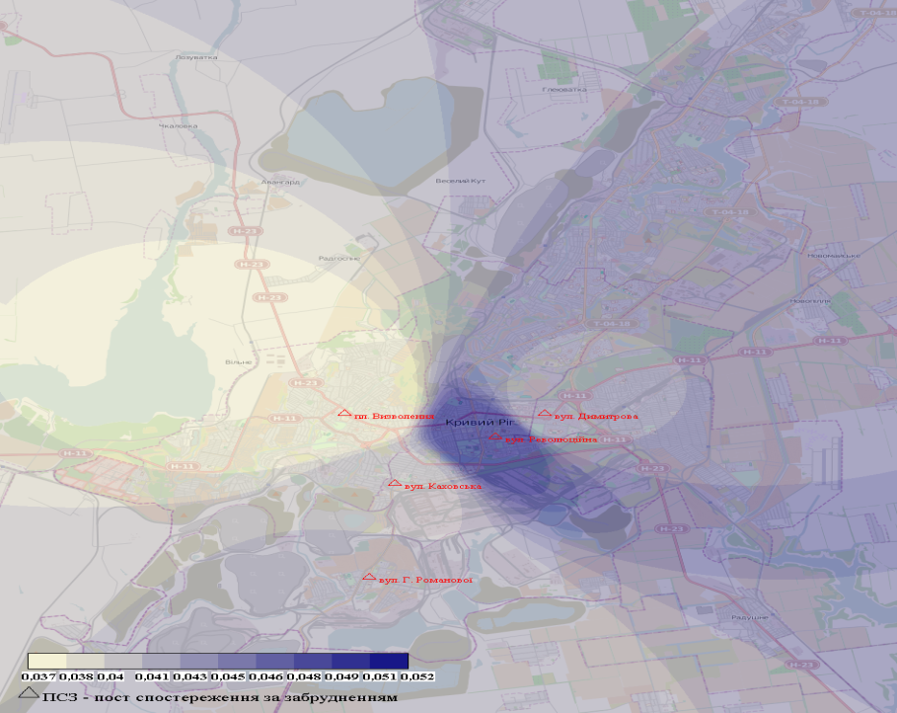
Pic. 6. The map of the cumulative impact risk assessment of NO₂ and SO₂ in the air of city Kryvyi Rih, mg/m³
Based on data obtained, common torch, formed over the city Krivyi Rig by overlaing of emissions of numerous companies of the group «Arcelor Mittal», can be transported with air over a distance of several tens of kilometers. The spatial structure of this torch is quite complicated, single concentrations of impurities in different venues are substantially different from one another. In the absence of constraining layers and a weak movement of air impurities quickly, rising up and falling with precipitation as acid rain.
Conclusion. According to monitoring data, the activity of a steel plant in the district of El-Hajar leads to the formation of areas of permanent airborn pollution with nitrogen dioxide, toluene and benzene not only in the industrial area, but also in the territories of residential infrastructure. The tendency to higher content of nitrogen dioxide in the atmosphere around the metallurgical plants of company «Arselor Mittal» indicates the existence of a risk of loss of nitric acid rain not only within the agglomerations but also in surrounding suburban areas. Further research should be aimed at determining the proper number of posts in the planning of activities to reduce the negative impact of harmful emissions on the environment.
BIBLIOGRAPHY
1. Тарасова В. В. Екологічна стандартизація і нормування антропогенного навантаження на природне середовище : навчальний посібник / В. В. Тарасова, А. С. Малиновський, М. Ф. Рибак. – К. : Центр уч. літ. – 2007. – 276 с.
2. Криваковська Р. В. Картографування забруднення атмосфери двооксидом азоту та сірки в індустріальних містах Дніпропетровської області / Р. В. Криваковська, М. М. Харитонов,
В. М. Хлопова. Картографування забруднення атмосфери двооксидом азоту та сірки в індустріальних містах. Екологічна безпека. – №2/2013 (16). – С. 32–35.
3. Karnaukh M. Social, medical and environmental consequences of mining and metallurgical complex activity in the Krivorozhsky region and decision making / M. Karnaukh, S. Lugovskoy // In: Barnes I., Kharytonov M., editors. Simulation and assessment of chemical processes in a multiphase environment NATO science for peace and security, series C: Environmental security. – Dordrecht, Netherlands: Springer. – 2008. – P. 377–384.
4. Semadi F. Faisabilit du traitement des eaux d’un oued charg en lments traces mtalliques (ETM) par filtres plants de macrophytes (Phragmites australis): cas de la rgion d’Annaba / F. Semadi // Thse de Doctorat, Universit d’Annaba. – 2010. – 225 p.
5. Tajine A. Toxicity of dust of dismissed complex of steel Annaba on some hematologic parameters of rabbit (Europeus) / A. Tajine, A. Courtois, H. Djebar // Environmental research journal. – 2008. – 2. – Р. 76–79.
6. Tlili N. Bio-indication of air quality in the Annaba city (East of Algeria) / N. Tlili, S. Zarrouk,
L. Boughediri, F.Chacai // Research Journal of biological sciences. – 2007. – 2(6). – 619 р.

