© 2018
Biliavska L. G., Candidate of Agricultural Sciences,
Vasetsky Yu. P., Postgraduate Student,
Pylypenko O., Applicant,
Biliavsky Yu. V., Ph.D. in Biology,
Diianova A. O., Specialist of the II Category
Poltava State Agrarian Academy
HIGH-ADAPTIVE SORT OF SOY AQUAMARINE
Reviewer – Doctor of Agricultural Sciences, Professor V. M. Pysarenko
The value of protein culture of soy, the universality of its use is shown. The ways of increasing soy production in Ukraine are considered. To the State Register of plant varieties, suitable for distribution, a significant number of various soybean varieties are listed in Ukraine, most of which have a narrow ecological-geographical adaptation. In modern conditions, the soybean must be highly productive, adaptive, with a high level of resistance to biotic and abiotic environmental factors. Based on long-term practical experience in soybean selection, the hybridization of sources of adaptability to stress factors of the environment resulted in a variety with a higher base potential. Aquamarine variety, entered in the State Register of plant varieties, is suitable for distribution in Ukraine. The morphological and biological characteristics of the variety are given.
Key words: soybean, variety, breeding, varietal characteristics, economic characteristics, adaptability, yield.
Formulation of the problem. Soya is a valuable oil and grain culture of world agriculture. Significant distribution of soy on all continents in many countries of the world is due to high qualitative indicators of grain, relatively low energy intensity of its cultivation, versatility of use [1, 2]. Its seeds contain: 38–45 % of protein, 18–23 % of fat, 25–30 % of carbohydrates, including soluble sugars – 9–12 % of the weight of seeds, starch – 3–9 %, fiber – 3–7 %, about 2 % phosphatides, 4–7 % of inorganic substances, trace elements, enzymes and vitamins.
In Ukraine, crop areas under soya grow rapidly. The country came out first in Europe with squares and volatile soybean production.
At the present stage of agricultural development, the variety remains not only a means of increasing yields, but also becomes a factor without which it is impossible to realize the accumulated genetic potential, to satisfy the requirements of the consumer and the processor [3]. National varieties of Ukraine are the basis of food security of the state. Due to the use of new high-yield varieties it is possible to significantly increase the production of soybeans.
Analysis of basic research and publications, which initiated a solution of the problem. By 2017, 170 varieties of soybean are listed in the State Register of Plant Varieties that are suitable for distribution [4].
Most modern varieties are characterized by a narrow ecological suitability and are suitable for cultivation in soil-climatic conditions of a certain geographical latitude [5–6]. In other zones of cooking in such varieties, changes in the length of the growing season, productivity, chemical composition of seeds, resistance to harmful organisms, stress and lack of knowledge of varietal characteristics are possible. Therefore, new high-yielding and adaptive varieties with high quality seeds should occupy large areas. Effective use of such varieties will increase the volume of soybean production. Among the new high-speed varieties, the Aquamarine variety has a significant value.
The aim of the study. The main objective of our research was the removal of high-yield soy varieties adapted to the conditions of the Forest-Steppe of Ukraine with the quality of seeds.
The method of conducting research. To create a variety, hybridization sources of adaptability to limiting factors of the environment and complex of climatic factors are involved. The studies were conducted in accordance with generally accepted methods. Morphological and biological features were determined according to the Uniform Classifier of the genus Glycine [7].
Research results. Long-term monitoring and evaluation of a variety in different regions of Ukraine demonstrated its high economic value, stability duration of the growing period, high yield, high protein content. We give it a morpho-biological characteristic.
Morphology. The type of growth is intermediate. The plant has a semi-shrunk bush, height of 70–80 centimeters (Pic. 1).
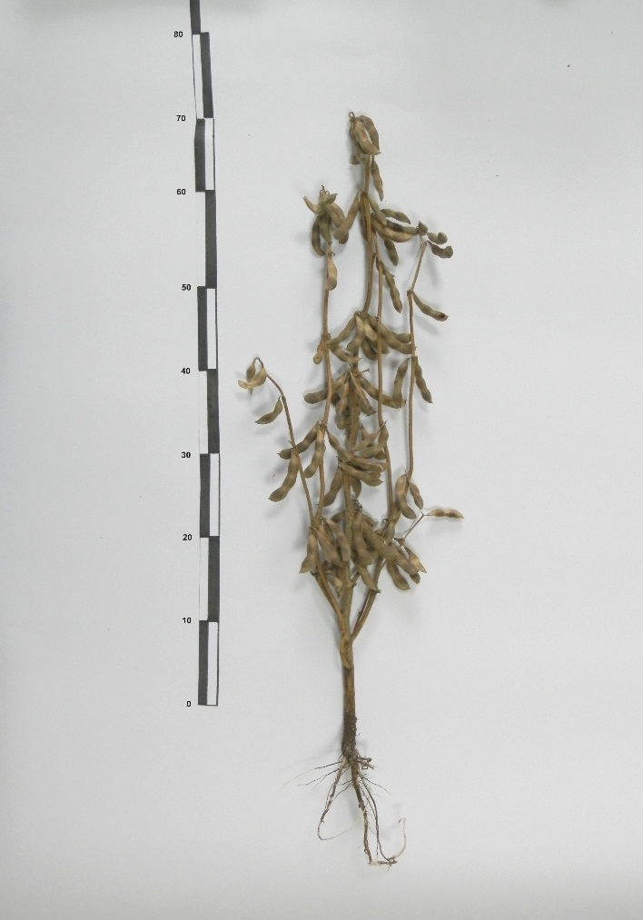 | 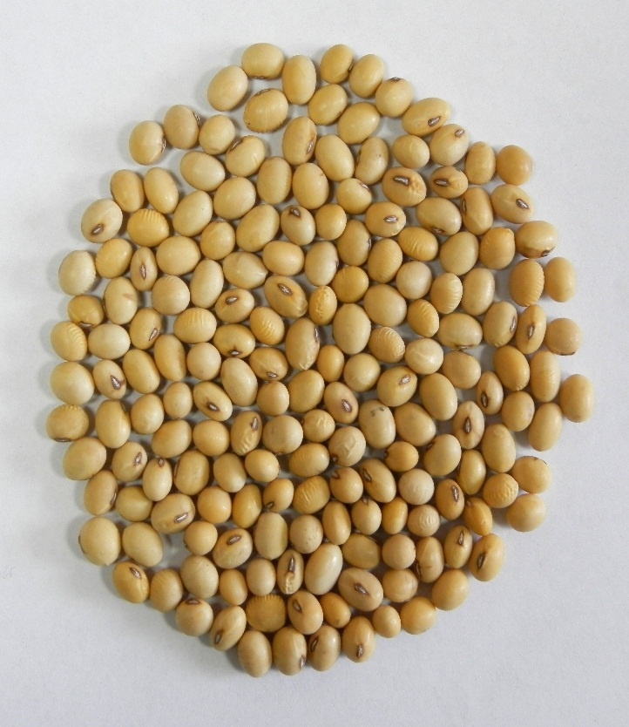
Pic. 1. General view of the plant of the variety | Pic. 2. Aquamarine seed
Stem of medium thickness are 7,0–12,0 mm, resistant to sinking. The color of the pubescence is gray. Number of internodes are 10–12 pieces. Number of branches are 1–3, the angle of their branch is 20–30º. The height of attachment of the lower bean is 15 centimeters. The root system is well developed.
The leaves are triangular, medium-sized. Inflorescence is a multiflorous goblet, 5–7 flowers. The color of the flower corolla is white. Beans sandy, with liquid ossification of sand, medium length, weakly curved with a sharp tip, with 2–3 seeds. Seeds are average (0.6 x 0.4 cm), round-oval (Pic. 2). The main color of the shell is yellow. The seminal scar is red with an eye. The weight of 1000 seeds is 170–180 grams.
The content of protein in the seed is 43 %, fat is 22 %.
Biological features. Guaranteed predecessor for winter crops. It successfully combines high productivity and quality of the seeds. Duration of the period from the appearance of stairs to flowering from 35–40 days. Different in geographical latitude regions have a stable vegetation period of up to 100 days. Potential yield of grain in the conditions of the Steppe and Forest-Steppe of Ukraine is 3.0–3.2 t/ha.
It has a neutral photoperiodic reaction that provides a stable vegetation period in different climatic zones. At the moment of reaching it quickly reaches the conditioned humidity and does not require drying.
Grain type of use. Resistance against falling and cracking of beans for a long period is high. The variety is resistant against bacterial and viral diseases, pests are damaged weakly. The Aquamarine brand is generally accepted for Ukraine. The norm of sowing 600–700 thousand pieces of similar seed per hectare. The variety is well responsive to fertilizing and pre-sowing inoculation of seeds with biologics. Depth of wrapping of seeds is 4–5 cm Characterized by increased adaptive ability to adverse conditions of cultivation, including before growing on acid soils (pH 4.5–5.5). Recommended for growing on grains in the Steppe and Forest-Steppe of Ukraine. Seed leveling is 95 %.
Conclusion. Grade is one of the important means of improving the productivity of culture. The successful selection of the variety significantly compensates for the negative impact on the expected crop of soil and climatic conditions of cultivation, the use of imperfect techniques, the deficit of mineral fertilizers and plant protection products, etc. Recommended for growing in the Ukrainian Steppe and Forest-Steppe Adaptive Soybean Class Aquamarine has significant potential and high yield stability over the years.
BIBLIOGRAPHY
1. Бабич А. О. Кормові і білкові ресурси світу / А. О. Бабич. – К. : Аграрна наука, 1996. – 822 с.
2. Білявська Л. Г. Особливості насінництва сортів сої селекції ПДАА / Л. Г. Білявська, О. В. Пилипенко, А. О. Діянова // Конкурентноспроможне насіння – стабільний урожай : тези міжнар. наук.-практ. конф., (30–31 січня 2013 р.). – Полтава : ПДАА. – 2013. – С. 55–56.
3. Білявська Л. Г. Високоадаптивні сорти сої Полтавської селекції / Л. Г. Білявська, О. В. Пилипенко,
А. О. Діянова // Посібник Українського хлібороба. – Мін. АПК. – Інститут рослинництва ім. Юр’єва. – 2013. – Т.2. – С. 150–151.
4. Державний реєстр сортів рослин, придатних для поширення в Україні в 2016 році [Електронний ресурс]. – Режим доступу : http://vet.gov.ua/sites/default/files/Reestr%2006042016.pdf.
5. Beliavskaya L. The results of study of ecological stability and plasticity of Ukrainian soybean varieties. – Annals of Agrarian Science. – Volume 15, lssue 2, June 2017. – Pages 247–251.
6. Сичкарь В. И. Селекция сои на адаптивность к факторам внешней среды : автореф. докт. дис. – Одесса, 1990. – 36 с.
7. Широкий уніфікований классификатор рода Glycine max (L.) Merr. – Х. : «Магда LTD», 2004. – 37 c.

