© 2016
Tanchyk S. P., Doctor of Agricultural Sciences, Professor,
Odarchenko O. M., postgraduate student
National University of Life and Environmental Sciences of Ukraine
INFLUENCE OF NO-TILL AND CONVENTIONAL TILLAGE ON THE NUMBER OF EARTHWORMS IN CROPS OF SPRING BARLEY OF THE RIGHT-BANK FOREST-STEPPE OF UKRAINE
The system of primary tillage is an integral part of growing crops technology. However, for organisms which use soil as a main habitat, any violation of top soil layer leads to disruption of almost all components microecosystem environment, including livelihoods of earthworms. At the same time to preserve and restore soil fertility is necessary to establish ways to improve existing technologies that facilitate the development of useful soil fauna. To achieve this goal we should work towards optimization of the basic soil tillage and fertilizer system, which must first manage crop residues for different tillage ways [2, 6].
Earthworms are among the most important organisms that are actively involved in soil formation processes. In the property improve of soil nutrient regime, soil structure and soil organic matter depends on the level of their activity. At the same time the development of populations of earthworms in the soil depends on the moisture content of organic matter, texture, pH and primary tillage systems [4, 5].
In the near future a major factor in increasing the crop yield will be able to use the biological activity of plants and soil organisms that affect the whole complex of soil processes. Thus, according to V. T. Hrydychyn (2013) by earthworms on soils fertilized only straw of previous crop barley yield can be increased almost 2 times. Using the technology of direct sowing we can provide increasing number of earthworms almost 40 times as compared with the use of conventional tillage. Earthworms also provide better infiltration of rain water in the lower layers of the soil. In addition, earthworms are able to process per day to 5 kg of organic residues on each hectare and convert them into a large amount of nutrients, providing formation to 5 t/ha of humus [1].
According to the research of K. Chan (2001), numerical changes in the population of earthworms significantly depend on the intensity of tillage. It was also noted that depending on the intensity and type of tillage the number of earthworms can decline to 2–9 times. Although the size of the population of earthworms was under the direct influence of tillage, but reported that it can grow even in deep plowing in case of additional crop residues. Researcher noted that in case of minimal tillage the role of earthworms increases significantly because of their ability to modify the physical properties of the soil and convert nutrients into available forms [3].
Despite the fact that issue of the impact of different tillage systems on the population of worms has actively being studied during the past 30 years in Ukraine this issue pays little attention.
Aim of researches was to study the influence of conventional tillage and no-till on the number of earthworms under spring barley in the condition of the Right-Bank Forest-Steppe of Ukraine.
Materials and methods of research. Fields researches were conducted in stationary experiment of National University of Life and Environmental Sciences of Ukraine «Agronomic Research Station» in short crop rotation during 2014–2015. The scheme of crop rotation: soybean – spring barley – corn.
The soil of research plots is typical, low-humus, medium-loam black soil, which contents 3,94 % of humus, absorption capacity – 32,5 %, total nitrogen content – 0,3 %, phosphorus – 0,25 %, potassium – 2,5 %.
Contents of research variants:
I. no-till – the absence of any mechanical tillage throughout the growing season, except for direct sowing in untilled soil;
II. conventional tillage – constant using of plowing to a depth of 20–22 cm in spring barley crop as the primary tillage.
Determination of the number of earthworms conducted by digging monolith size 25x25 cm, followed by its division into layers 0–10, 10–20, and 20–30 cm. Accounting was performed at the beginning of the growing season and before harvesting of spring barley.
Results of researches. Applying over the past 10 years direct drilling technology helped to create favorable conditions for populations of earthworms in the upper layers of the soil (see table). On average, 2 years of research the number of earthworms in the layer 0–30 cm was 210 units/m², which is 2,6 times higher than in case of conventional tillage.
However, if we analyze the data in the table, we can conclude the dynamics of this indicator over time. The largest number of worms was observed at the beginning of the growing season of spring barley on both types of tillage. However, the decline of earthworm population in variant of no-till was less sharp compared to plowing. On average for 2014–2015 years the number of earthworms in zero tillage on harvesting of spring barley in 0–30 cm soil layer was 132 units/m², which is 2,3 times less compared with the index at the beginning of the season.
Number of earthworms per 1 m² under conventional tillage and no-till of spring barley

In plowing variant we noted a sharp fluctuation of this index, where we observed its decline by 9 times. Based on the results, we can conclude that in conventional tillage it is much unproductive loss of moisture and direct sunlight causes it to heat the top layer to high temperatures, all of which negatively effect on the population of earthworms.
Tillage type | Soil layer, сm | 2014 |  | 2015 |  | Average
Tillage type | Soil layer, сm | Sowing | Harvesting | Sowing | Harvesting | Average
No-till | 0–10 | 232 | 112 | 208 | 88 | 160
No-till | 10–20 | 80 | 40 | 72 | 24 | 44
No-till | 20–30 | 16 | 0 | 8 | 0 | 6
Plowing | 0–10 | 96 | 24 | 88 | 8 | 54
Plowing | 10–20 | 56 | 0 | 40 | 0 | 24
Plowing | 20–30 | 8 | 0 | 8 | 0 | 4
LSD₀₅ (tillage) |  |  |  |  |  | 35
LSD₀₅ (soil layer) |  |  |  |  |  | 43
LSD₀₅ (interaction) |  |  |  |  |  | 60
If we look at the distribution of earthworms in the soil layers, in both cases there was a similar pattern with some differences. As a result, for the 2 years of zero tillage in the layer 0–10 cm was 76 % earthworms of the total in the 10–20 cm layer – 21 % and 3 % of 20–30 cm, under plowing the distribution in the layers was respectively 66, 29, and 5 %. Therefore, for zero tillage the main amount of earthworms (76 %) is concentrated in the upper (0–10 cm) soil layer, where the gross stubble of last year's crop residues. In the variant of conventional tillage despite the fact that the crop remains found at a depth of 15–20 cm, but most of earthworms (66 %) was also concentrated in the upper layer, but their distribution is less pronounced than under direct sowing.
One of the key factors that express the efficiency of cultivation technology is achieved crop yield. According to no-till average yield for the studies years was 4,73 t/ha, which is 0,36 tons higher compared with traditional cultivation, but this difference is within the least significant difference.
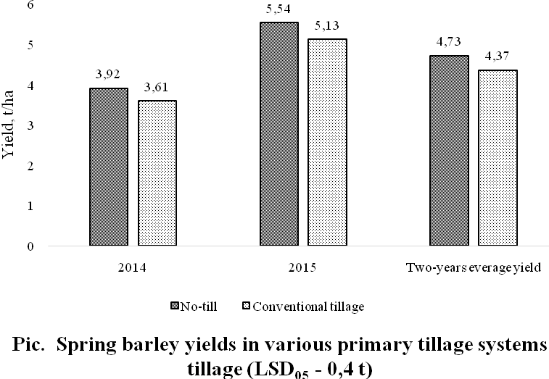
Conclusion. Implementation of system farming of no-till for cultivation of spring barley in Right-Bank Forest-Steppe of Ukraine ensures the accumulation of crop residues in the top layer of soil that provide more effectively moisture using, which in turn contributed to a significant increase in the population of earthworms in the upper layer of soil (0–10 cm) compared with conventional tillage.
Prospects for further research are the implementation of stubbly crops in no-till, which will additionally accumulate even more plant residues, which will stabilize the number and activity of earthworms during the growing season.
BIBLIOGRAPHY
- Гридчин В. Т. Его величество – червячок / В. Т. Гридчин : матеріали міжнар. семінару [«Практичне природне землеробство: якість продукції, ефективність, перспективи»] (листопад 2013 р.). – Мелітополь, 2013. – С. 144–146.
- Abundance and distribution of earthworms in relation to landscape factors on the Georgia Piedmont / [Hendrix P., Mueller B., Bruce R., and others] // Soil Biology and Biochemistry. – 1992. – №24. – P. 1357–1361.
- Chan K. Y. An overview of some tillage impacts on earthworm population abundance and diversity: implications for functioning in soils / K. Y. Chan // Soil Tillage Research. – 2001. – №57. – P. 179–191.
- Curry J. P. Intensive cultivation can drastically reduce earth worm populations in arable land / J. P. Curry, D. Byrne, O. Schmidt // European Journal of Soil Biology. – 2002. – №38. – P. 127–130.
- Edwards C. A. Earthworm Ecology / C. A. Edwards. – Boca Raton : CRC Press, 2004. – 456 p. – (2nd ed.).
- Van Capelle C. Tillage-induced changes in the functional diversity of soil biota – A review with a focus on Germandata / C. Van Capelle, S. Schrader, J. Brunotte // European Journal of Soil Biology. – 2012. – №50. –
P. 165–181.

