Panasenko S. I., Burlaka A. A., Yakhin S. V.
JUSTIFICATION OF THE CHOICE OF THE CONSTRUCTIVE SCHEME FOR THE DEVICE OF EXTERNAL FIXING OF THE FLOATING THORAX FRACTURE
According to the known scientific research [1–4 in bibliography] a significant amount of injuries of a thorax is followed by the floated changes of a sternum-rib framework.
As the known researches of domestic and foreign scientists show, for example, Burluk V. V., Nirula R., Mayberry J., lethality in case of the floated fracture of edges of a thorax is more than 20 % [1, 5].
Unfortunately, in Ukraine military operations and quantity of injuries with flotation of a thorax significantly are conducted increases as the cases of floatation fractures of thorax caused by hit of an automatic bullet in the military bullet-proof vest meet. Therefore, researches are directed to improvement of methods and remedies for floatation changes of a sternum-rib framework are extremely relevant and important.
Purpose and research problems – development of actions and recommendations about possible reduction of extent of surgery by the choice of the optimum constructive scheme of the device of external fixing of fragments of edges at a floatation change of a sternum-rib framework.
When carrying out these researches methods of observation and comparison of results of use of the frame-rod device of external fixing of floatation changes of fragments of edges of a sternum-rib framework in surgical practice of humane medicine are used.
The floatation phenomena in injured a thorax of the person arise as a result of fragmentary fractures of three and more edges that leads to local disturbance of the bearing ability of a sternum-rib framework. Flotation is shown in the form of «antiphase» the movements of a chest wall when on the act of a breath the damaged site of a fragment of edges sinks down inside, and on the act of an exhalation, on the contrary – is curved outside. At the same time the muscular activity of a sternum-rib framework considerably decreases at the expense of a pain syndrome. It leads to formation of an additional cavity in a thorax behind which the normal difference of pressure is broken and process of air exchange in lungs worsens.
Modern known methods of treatment of floatation fractures of thorax are the internal and external osteosynthesis using various means of fixing. Various methods of fixing have both advantages, and shortcomings. However, practice of use shows what external threw – an osteosynthesis of the floated change of a sternum-rib framework possesses significantly the best clinical effects of treatment and allows to reduce treatment time in comparison with internal [4, 5].
From the point of view of technical mechanics, the sternum-rib framework is the bearing space rod design which perceives loadings from a difference of internal and external pressure and also from the efforts caused by reduction of muscles. The thorax performs the functions in an organism at the expense of own durability and rigidity that allows it to provide protection of internals and a possibility of artificial creation in lungs of pressure is higher and lower than breath, atmospheric during implementation of acts.
The floatation fracture of a thorax is a case of partial loss of durability of the bearing design of a sternum-rib framework at which conditionally static elements of a design of a sternum-rib framework turn into the mechanism with is limited by mobile links. The osteosynthesis of a sternum-rib framework is directed to recovery of rigidity and durability of the injured thorax.
The frame-rod device (pic. 1) gives the positive takes of treatment and full static fixing of degrees of freedom arising at the floatation movements.
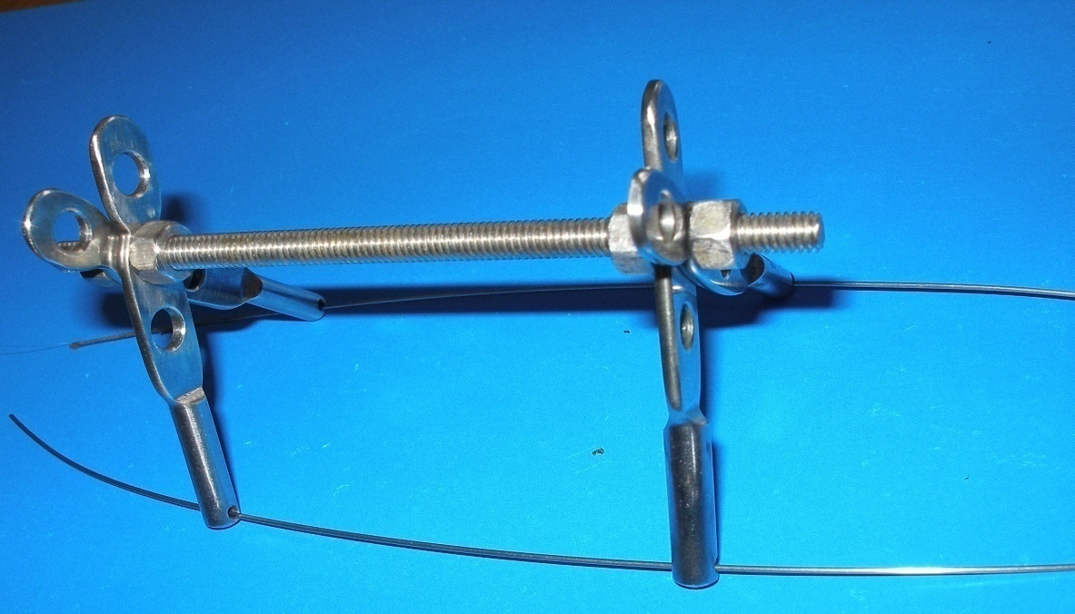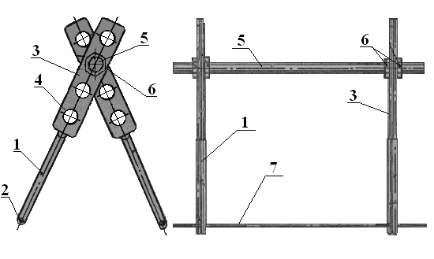
Pic. 1. Outward and scheme of the device of external fixing: 1 – round part of a basic core; 2 – a head with an opening for a needle of a basic core; 3 – a flat upper part with openings of a basic core; 4 – fixture for fixing;
5 – external basic hairpin; 6 – the fixing nuts; 7 – traumatologic needle.
Basic elements of such device (pic. 1) is traumatologic needles 7, vertical basic cores 1 and external basic hairpins 5.
The way of fixing of edges developed by us the device of external fixing consists in carrying out needles through a breast and edges and installation on them basic elements of an external medical metalwork (pic. 2) [4, 5].
Basic elements of the device of external fixing have to contain, at least, two contact nodes – one for interaction with needles, the second for interaction with other basic elements (pic. 2).

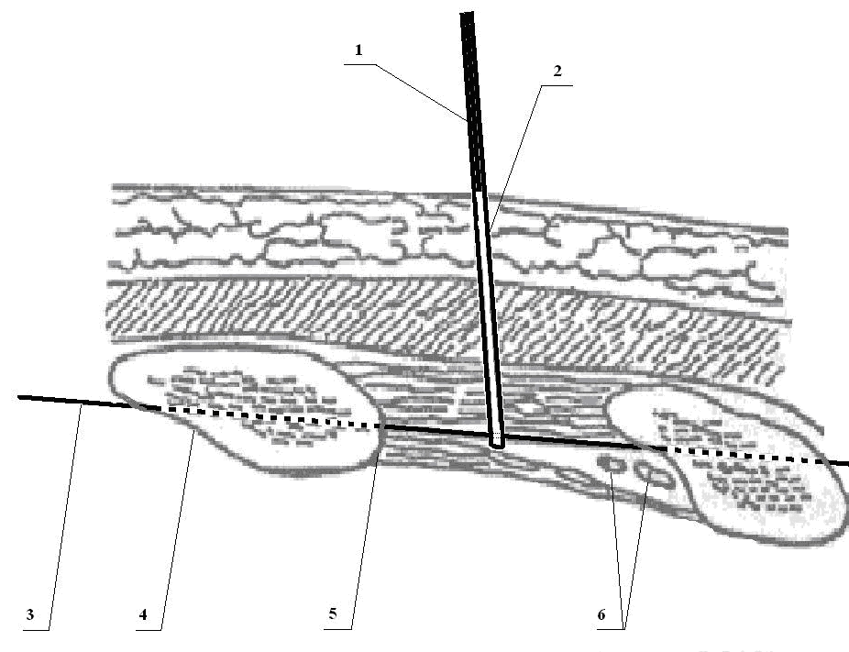
Pic. 2. Schematic image of a way of carrying out traumatologic needle and installation of a basic vertical core.
1, 2 – nodes of interaction of a basic vertical core;
3 – traumatologic needle; 4, 5 – the lower and upper cortical layers of an edge; 6 – intercostal neurovascular bunch.
The needle 3 is carried surely out from below – up the relation to an edge so that when sliding a tip of a needle from bottom edge of an edge the intercostal neurovascular bunch without its damage was taken away. Right after passing upper a cortical layer of an edge manually through skin define a tip of a needle and in its projection do a section of skin 2–3 mm, sufficient for carrying out through it a basic element. The basic element is fixed on a needle immersing it in a section. The needle is carried out further, directing its movement by means of a basic element. Carry out by a similar way other needles and fix on them enough basic elements.
After carrying out needles and installation on them basic elements, by means of the last model a design of the beam-rod device of external fixing.
For elimination of the costal valve where three and more edges are broken and in case the floated valve has the considerable sizes, it is reasonable to use a space design with four external basic hairpins (pic. 3). The space design with use of elements of such device completely fixes the undesirable degrees of freedom arising at a floatation change of a sternum-rib framework (pic. 3).

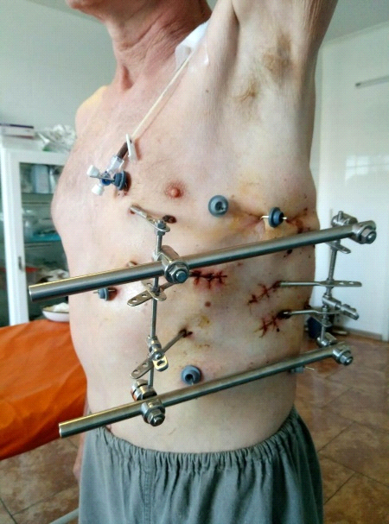
Pic. 3. Use of the frame-rod device with external basic hairpins for fixing of several adjacent edges of the broken-out fragment of a sternum-rib framework according to the scheme of an external rectangle.
Also one of ways of fixing of fragmentary fractures of edges is the external osteosynthesis with partially removed nodes [2, 3, 4] (pic. 4). Need of use of triple combined nodes caused by elimination of a deflection of the broken-out part in places where installation of additional fixing hairpins causes inconveniences or is impossible taking into account anatomy of the patient.

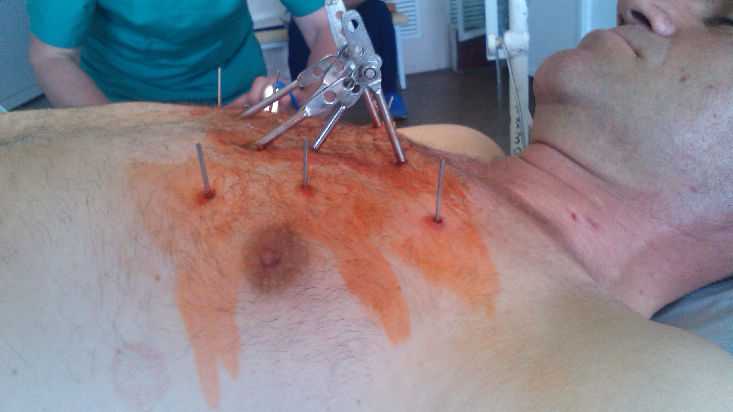
Pic. 4. Use of the frame-rod device for local fixing of several adjacent edges of broken out fragment of a sternum-rib framework according to the scheme with partially built cores.
Such system of fastening allows to fix fragmentary changes of a sternum-rib framework in more local zone. At the same time the unimpaired parts of a thorax which are directly located close change zones become basic elements of fixing.
If at the patient it is revealed several separate fragmentary changes having branched out dislocations and are removed from each other on considerable distances, then in that case a combination of cores with four and more basic hairpins inconvenient and it is not always possible from the point of view of practical execution. Also preventive actions for processing of surgical wounds become complicated, the probability of pain of the patient at the expense of inadvertent physical impact on elements of a design of the device of external fixing increases, also difficulties of movements of the patient are added.
In more difficult cases it is possible to combine use of summary nodes and external basic hairpins (pic. 5).

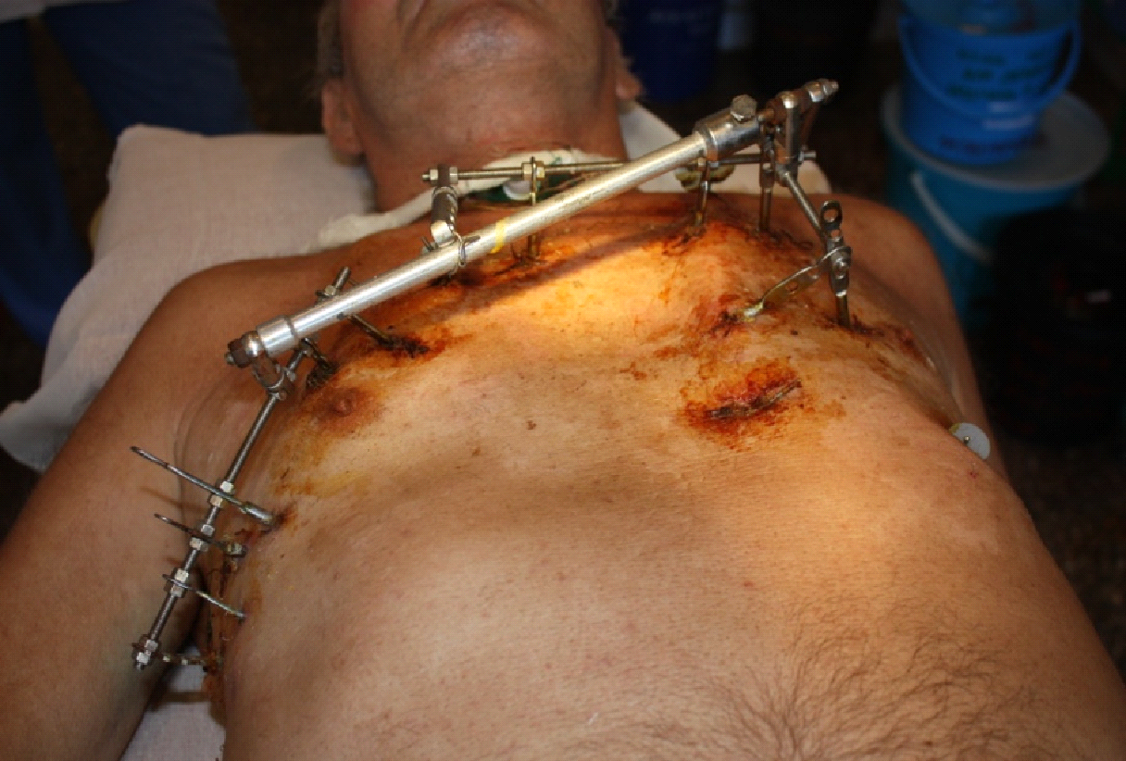
Pic. 5. Use of the device of external fixing with summary nodes and external hairpins at treatment of difficult multiple fractures on the combined scheme.
Such technology of installation of the device of external fixing is a compromise on recovery of rigidity and durability of a sternum-rib framework with minimum possible quantity of the fixing elements at difficult multiple fragmentary fractures of a thorax, followed by flotation.
Thus, use of the approach directed to elimination of the degrees of freedom arising at floatation changes with use of provisions of engineering mechanics and the theory of machines and mechanisms allows to analyze behavior of a thorax, in different cases of its damage, the flotations which are followed by the phenomenon and to reveal the main lines of design of an optimum design of the device of external fixing, to prove the minimum quantity of elements of its design and to analyze options of performance of an osteosynthesis.
Results of the conducted research are a basis for further development of an optimum design of the device of external fixing and performance of design calculations of its elements and nodes.
Key words: external fixation device, floating fracture, chest, method of fixation, constructive scheme.

