© 2016

Kovnir D. A., postgraduate student

(scientific supervisor – PhD in Economics, Associate Professor I. A. Kondratyuk)
Kyiv National Economic University named after Vadym Het’man
Mechanism of administrative decision making by a state higher educational institution on the basis of analysis results
Reviewer – Doctor of Economic Sciences, Professor V. V. Pysarenko
The author’s own definition of the concept «managerial decision» is offered in the article, the model of decision making through analyzing the levels of performance indicators of the financial mechanism of state higher institution has been created and the complex system of typical model administrative decision making by a state higher educational institution on the basis of analysis results has been developed. The recommendations on administrative decision making according to the analysis results of economic activity have been provided.
Keywords: mechanism, managerial decision, state higher educational institution, analysis findings, model, modeling.
Statement of the problem. No institution, company or organization can operate effectively without a proper system of managerial decisions based on the topical issues of the institution (company) position, its possible changes and further development. The analysis of economic activities of an institution is the most essential for making managerial decisions.
The reason for analyzing the information presented in financial statements is the availability of reporting forms for internal and external users, a high degree of data aggregation covering all aspects of the entity, the possibility of multilateral financial analysis. Therefore, the problem of developing of decision making mechanism on the basis of analysis findings is becoming a topical issue [8, 10].
Analysis of recent research and publications on this issue. The issue of managerial decision making by institutions was studied and discussed in the works of many prominent scientists including
Yu. Yu. Benedyk [1], T. M. Boholib [2], I. M. Gryschenko [4], V. P. Martyniuk [7], V. A. Matyukhin [8], and I. S. Stetsiv [11].
However, in the light of a huge amount of research on this subject, the mechanism of managerial decision making by a state higher educational institution on the basis of analysis findings needs more detailed study.
Purpose of research. Development of a holistic evidence-based mechanism of managerial decision making by a state higher school on the basis of analysis findings.
Tasks of research:
- to study the essence of the concept «managerial decision»;
- to investigate the mechanism of managerial decision making;
- to analyze the system of managerial decision making by a state higher educational institution on the basis of analysis findings.
Research results. A managerial decision is a set of a manager’s activities aimed at solving topical issues of an institution.
In general, the term «decision» is understood and interpreted differently. Because of its diversity it is seen as both the result of choice and act. As for managerial decisions of state higher educational institutions in particular, a number of requirements are set, such as:
- timeliness – a decision must be made in a specific time (neither earlier nor later than a fixed time);
- completeness – a decision must fully disclose its content, cover the entire object that is managed;
- authority – a manager’s strict implementation and compliance with her/his rights and responsibilities;
- legality and legitimacy – a managerial decision should not contradict the norms of the existing legislation;
- feasibility – the ability to implement a decision;
- effectiveness – ensuring positive results from implementation of a decision;
- clarity – a decision should be brief, concise and understandable;
- scientific validity – a managerial decision must be valid and confirmed by the relevant information.
The problem of the mechanism of managerial decision making on the basis of analysis findings has been studied in the context of state higher educational institutions, as a modern higher school is a complex dynamic system. The complexity of the system is determined by the variety of activities including training specialists at various levels, implementation of scientific research, and auxiliary areas of work. In the meantime, all activities are interdependent, both at the level of manufacturing processes and the organizational level.
Because of the diversity of its activities, a state higher school has a complex production structure. The main parts of this structure are university administration, faculties, departments and supporting units. The effectiveness of managing such complex structure and material expenses are the main conditions of the high-quality scientific and educational process [8].
The model of decision making on the basis of the analysis of the levels of performance indicators of the financial mechanism of state higher educational institutions is given in picture 1.
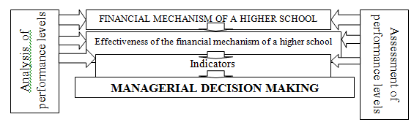
Source: it is compiled by the author and based on the data [10].
Pic. 1. The model of decision making on the basis of the analysis of the levels of performance indicators of the financial mechanism of state higher educational institutions
It should be noted that managerial decision making requires a high level of professionalism and knowledge from a management entity. Unfortunately, today only about 5–10 % of people making managerial decisions are competent in their work. In addition, a number of factors influencing the effectiveness of managerial decision making by a state higher educational institution has been revealed during the study. These factors include the use of scientific approaches and principles to a project management system, modeling techniques, methods of automatic control theory, methods for motivating quality decisions and others. As a rule, three main things – intuition, judgment and rationality – are usually available in any decision making [5].
We can note that the need for managerial decision making is caused either external circumstances (the order of a superior organization, regulation of relations with companies and organizations) or internal ones (strategic objectives of the organization, deviation from the defined parameters of production, emergence of bottlenecks, identification of reserves, violation of labor discipline, incentives for employees etc.). We have developed the own complex system of typical model of managerial decision making by higher schools (Pic. 2).

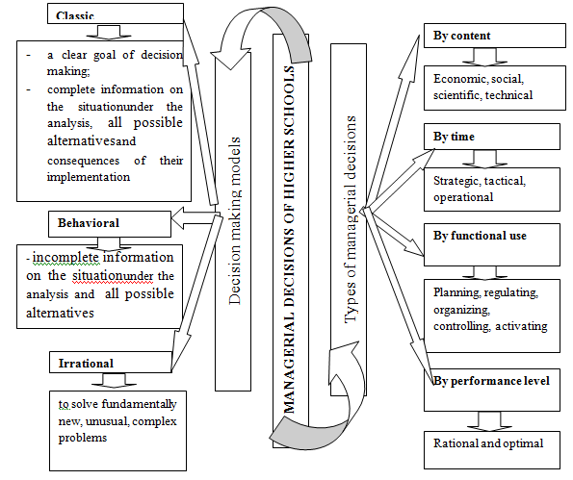
Pic. 2. The complex system of typical model of managerial decision making by higher schools
According to the results of the conducted analysis, managerial decisions are made within a framework of the classical model.
Managerial decision making by state higher educational institutions is achieved stepwise, i.e. there is a distinct consistency. The first step involves the analysis of the economic situation, setting of topical issues, study of the main factors causing them, collecting and processing of information. The second stage implies the formation and detailed analysis of decisions, identification and selection of the most effective one and its implementation.
The mechanism of managerial decision making by a state higher educational institution on the basis of analysis findings is shown in picture 3.
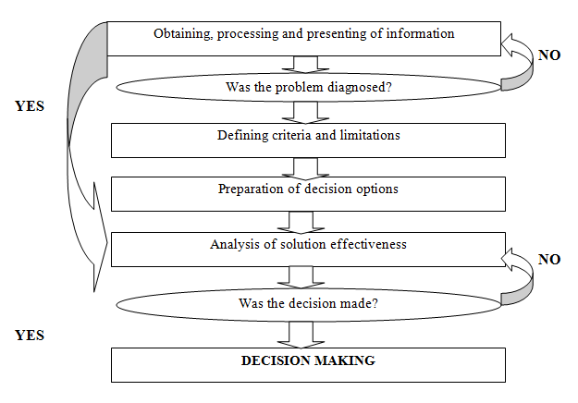
Source: it is compiled by the author and based on the data [8].
Pic. 3. The mechanism of managerial decision making by a state higher educational institution on
the basis of analysis findings
An important element of managerial decision making is assessment of actions at various stages. Therefore, it includes assessment of boundaries, scopes and prevalence of the problem at the stage of the problem diagnosis; it involves evaluation of different options offered to solve the problem at the stage of problem justification; assessment of expected consequences resulted from this decision is conducted at the decision making stage. This assessment is carried out according to certain criteria. The most frequent criterion of problem recognition at the preparation stage is the defined goal with the deviation showing that the problem exists. Consequently, managers at all levels must have clearly defined goals and objectives of their activity. Without them, the emergence of a problem is perceived purely intuitively or after receiving signals that significantly complicates the decision making process. Various criteria are used at the stage of development of decision making options to solve the problem; it allows you to choose the ones that are the most appropriate. The quality of managerial decisions and, ultimately, adaptability and efficiency of an organization depends on validity of these criteria [6].
Managerial decision making on the basis of analysis findings becomes structured because the construction of a model will form its basis. The application of modeling is aimed at a detailed study, maximum improvement and obtaining the optimum result by building models. The purpose of analytical models is to optimize the form of the economic information and research methods. The use of models enables to focus on key trends, processes and phenomena.
The main goal of modeling is to create conditions for timely and effective managerial decision making and to optimize the managerial process at a higher school. The construction of a model is based on the results of the preliminary analysis of a higher educational institution. Therefore, analysis findings affect the essence of certain managerial decisions. If the financial position of a higher school is satisfactory according to the analysis findings, the institution is developing and competitive in the market, therefore managerial decisions will be made in order to maintain the existing state of a higher school. Otherwise, when the analysis findings indicate a problematic state of higher educational institution, managerial decisions will be aimed at improving the institution operation.
From this study we can confidently assert that there is a close relation between analysis findings and managerial decisions; this relation should be considered by a state higher educational institution. The following elements should be taken into account:
1. The financial component is a leading and critical one because finances are the basis of any economic system under the market economy.
2. Intellectual and personnel components covering the work with the teaching staff.
3. The technical component which describes the logistical support of the academic process.
Informational and technological components are also important. The first one contains the information about compliance with the requirements of curricula; the second one involves a combination of information on the external environment (it is formed outside of a higher school) and on the internal one (it is formed directly during the economic activity of a higher school) [11].
So, having regard to the above, we can make a conclusion that managerial decision making by a state higher educational institution on the basis of analysis findings can lead to timely and effective changes in the managerial process of higher schools, scientific substantiation of managerial decisions, and potential managerial decision making.
Conclusion. The essence of the concept «managerial decision» has been substantiated and the mechanism of managerial decision making by state higher educational institutions on the basis of the economic information has been studied in this article. Ultimately, we can say that there is a close relation between analysis findings and managerial decisions, as we can make the valid managerial decisions aimed at the effective operation of a state higher school only on the basis of the analysis findings.
BIBLIOGRAPHY
1. Бенедик Ю. Ю. Взаємозв’язок між фінансовою стійкістю державного вищого навчального закладу та якістю освітніх послуг, які він надає / Ю. Ю. Бенедик // Науково-методичний журнал «Нова педагогічна думка». – Рівне, 2009. – Спецвипуск №1. – С. 71–78.
- Боголіб Т. М. Принципи управління вузом / Т. М. Боголіб. – К. : Знання, 2004. – 204 с.
3. Гурч Л. М. Логістична та маркетингова орієнтація ринку освіти в Україні в контексті Болонського процесу / Л. М. Гурч // Концептуальні засади формування менеджменту в Україні : збірник матеріалів Всеукраїнської науково-практичної конференції. – К. : МАУП, 2006. – С. 280–297.
4. Грищенко І. М. Економічна діяльність вищих навчальних закладів / І. М. Грищенко [Електронний ресурс]. – Режим доступу : http://er.knutd.com.ua/bitstream/123456789/790/1/V90sp_ P021-028.pdf.
5. Колпаков В. М. Теория и практика принятия управленческих решений : учеб. пособие / В. Н. Колпаков. – К. : МАУП, 2004. – 504 с.
6. Мармаза О. І. Інноваційні підходи до управління навчальним закладом [текст] : навч.-метод. посібник / О. І. Мармаза. – Х. : Основа, 2004. – 240 с.
7. Мартинюк В. П. Економічна безпека вищих навчальних закладів в Україні: передумови оцінювання. Економіка Менеджмент Підприємництво, № 25(ІІ) / 2013 / В. П. Мартинюк [Електронний ресурс]. – Режим доступу : http://eme.ucoz.ua/pdf/252/24.pdf.
8. Матюхін В. О. Організаційна модель та особливості менеджменту вищого навчального закладу / В. О. Матюхін, О. В. Кобзєва // Наукові праці МАУП. – К. : МАУП, 2006. – Вип.1(13). – С. 32–36.
9. Матюхін В. О. Організація практичної підготовки і використання інформаційних технологій при очно-дистанційному навчанні / В. О. Матюхін, О. В. Кобзєва : матеріали V Міжнародної наукової конференції «Реалізація положень Болонської декларації в системі вищої освіти і науки України», м. Судак. – К. : МАУП, 2005. – С. 247–253.
10. Моісеєнко О. П. Оцінка показників діяльності вищого навчального закладу в процесах прийняття управлінських рішень / О. П. Моісеєнко // Праці Одеського політехнічного університету. – 2011. – № 3. – С. 255–258.
11. Стеців І. С. Економічна безпека ВНЗ: сутність та особливості планування / І. С. Стеців [Електронний ресурс]. – Режим доступу : http://vlp.com.ua/node/6624.
12. Федулова Л. І. Актуальні проблеми менеджменту в Україні / Л. І. Федулова. – К. : Фенікс, 2005. – 320 с.

