© 2018
Oliinyk O. O.
PECULIARITIES OF SUBSTRATE SELECTION FOR IN VIVO ADAPTATION OF PLANTS-REGENERATES OF ROSE ESSENTIAL OIL
In research we studied substrates selection for successful adaptation of rose essential oil (variety Lan’) after microclonal propagation. The results showed that the most advisable is to use a mixture of peat and perlite in a ratio of 2:1. The survival rate of plants on the peat mixture with river sand was 70 % after 14 days of adaptation period. In the corresponding period this index was 62 % on a coconut substrate without impurities and 60 % on a coconut substrate with perlite. Using of a single-component substrate for the adaptation of rose essential oil are inadvisable, because the adaptation efficiency doesn’t exceed 50 %.
Key words: rose essential oil, plant-regenerant, in vivo, adaptation, substrate.
Formulation of the problem. In Ukraine, the demand for essential oil plants significantly exceeds the supply of production, which is due to the spread of infectious diseases. It leads to the loss of the required qualities, the deterioration of the physiological state of plants and the decline in plant productivity. Alternative to traditional methods of plant breeding, is the introduction of modern biotechnology methods, among which the microclonal reproduction takes the lea [7]. Propagation of plants in culture in vitro involves stepwise operation. One of the decisive stages of microclonal reproduction is the adaptation of plants-regenerant to in vivo conditions, which includes adaptation to the substrate and to the open soil conditions. Up to 50–60 % of plants die at the stage of adaptation due to violation of their activity of breaths and excessive dehydration of tissues [3]. The key to successful adaptation of regeneration plants to in vivo conditions and efficient seedlings growing in containers is the optimized substrate composition which promotes adaptation, increased liveliness, accelerated growth and development of plants.
An analysis of the latest research and publications that initiated the solution to the problem. The rose essential oil grows well on humus-rich soils that contain all the elements of nutrition. Among them are considered the best the deepest sandy black earths, the leached and medium-damaged loamy soils, as well as the dark-brown mountain-forest soils of the Southern coast of Crimea [6]. The process of adaptation combines traditional ex vitro cultivations and a sterile culture in vitro. It is known from literary sources that there are factors that complicate the healing of regenerants obtained in culture in vitro. So, according to O.N. Dediukhina [3] and E.B. Kirichenko [4], in plants, which were grown almost at 100 % humidity of air, the leaves had constantly open breaths. They needed high humidity in the culture medium. In this connection, there was a water shortage, created by high transpiration of leaves and low absorption capacity of the roots. For successful adaptation of plants in vivo, according to N.I. Turovsky and O.V. Strigina [8] it is necessary to create conditions close to the conditions of cultivation on a nutrient medium. The temperature of cultivation usually should correlate with the temperature of natural growth – 20–26 С, at high air humidity (90–100 %) and 16-hour photoperiod with illumination of 2000 km.
The purpose of the research is to find the optimal type of substrate for the effective adaptation of rose essential oil variety Lan, clones to the conditions in vivo.
Objective: to analyze the influence of substrates on the adaptive indices of plants-regenerate of the rose essential oil variety Lan.
Materials and methods of research. The object of research was the sort of roses of rose essential oil variety Lan of Ukrainian selection. The adaptation of plants-regenerantes was carried out according to the standard method of V.A. Vysotsky [2] and R.G. Butenko [1]. In vivo conditions were adapted plants-regenerantes with optimally formed root system and vegetative mass. The research was carried out in the adaptation room of the educational-scientific laboratory of virology and biotechnology of the National University of Life and Environmental Science of Ukraine. At a regulated temperature of 22–25 ° C, relative humidity of 70–75 %, illumination of 2.0–3.0 kcal and a 16-hour photoperiod. Seedlings had a well-developed aboveground part (shoots length not less than 3.5 cm) and well-branched root system (5–7 cm). Biological repeatability – 20 pieces of regeneration plants. Taking into account the bio-ecological features of the rose essential oil and the specifics of growing its seedlings in the container culture were used in the study different substrates (coconut substrate, sawdust, perlite, sandy river, soddy soil) and mixtures of them.
Research results. According to the results of our research [9] was developed the microclone propagation technique, which made it possible to obtain genetically stable, free from diseases plants-regenerantes of rose essential oil with an optimally formed root system and vegetative mass (Pic. 1).
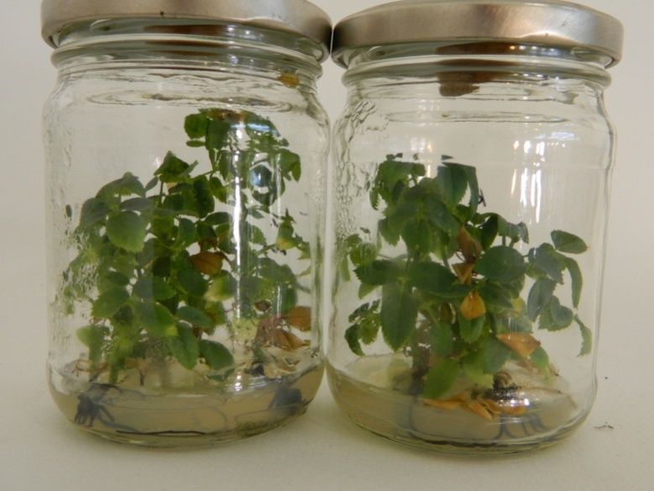
Pic. 1. Formed plants-regenerantes of rose essential oil
In order to evaluate the adaptation efficiency, the frequency of plant's livelihood was determined, using different substrates and their mixtures. When adapting regeneration plants to the conditions of closed soil, it is important to ensure the appropriate levels of plant nutrition: mineral, air, water, compliance with the gradual change in temperature and humidity of the environment. The substrate is essential which must contain enough elements of mineral nutrition, to have optimum permeability, air permeability and thermal conductivity. The substrate is essential and must contain enough elements of mineral nutrition, to have optimum permeability, air permeability and thermal conductivity. One of the important characteristics of the substrate is the moisture content, which should provide sufficient solubility of the elements of mineral nutrition and promote their uniform distribution. In addition, the substrate should be comfortable in operation, affordable and relatively cheap. The most common substrate for the adaptation of tree species, in particular the family of Rosa L., is peat-sand and peat-perlite mixes [10]. The popularity of peat as a substrate is due to its high permeability and fairly stable moisture content. At the same time, peat is characterized by high acidity (pH = 3.5–5.5) and excess moisture content, so it is used in a mixture with other more inert materials. We selected 10 substrates for the adaptation of the rose essential oil regenerators. They are divided into two groups: one-component (peat, perlite, coconut substrate, river sand, sod ground, sawdust) and multicomponent (peat:sand river 2:1, peat:sand 1:1, coconut substrate:perlite 1:1, peat:perlite 2:1). At the first stage of adaptation (5–7 days), regenerators were fed with a solution of the half concentration of mineral salts in the formulation of the nutrient medium Murasigu-Skuga (MC) [5]. As a result of the research, it was found that the use of a single-component substrate for the adaptation plants regenerantes of rose essential oil is not feasible, since its effectiveness does not exceed 50 % (Pic. 2).
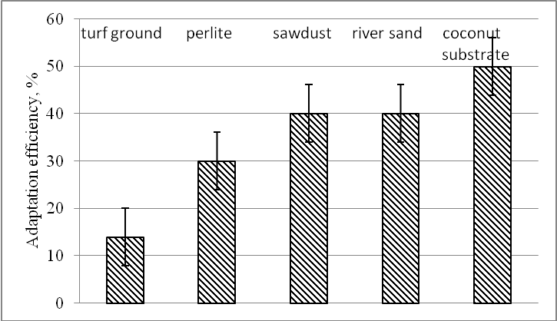
Pic. 2. Efficiency of adaptation of plants-regenerantes of rose essential oil on one-component substrates
For the use of sod soil as a substrate has been obtained an extremely low adaptive efficiency, which in our opinion can be explained by the sealing of the substrate during the irrigation of plants and its excessive moisture content.
It has been established that for adaptation of regenerants the use of two-component substrates is more effective than one-component substrates (Pic. 3).
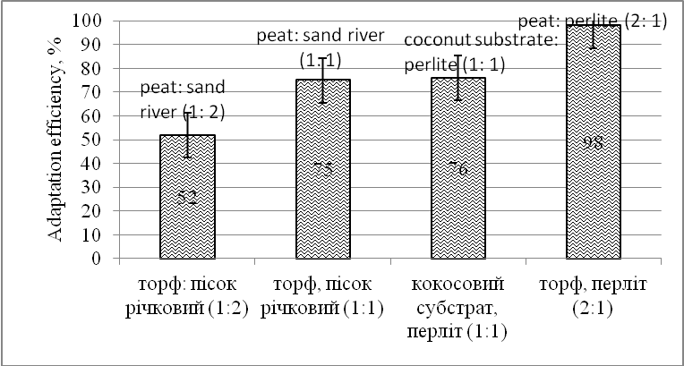
Pic. 3. Efficiency of adaptation of plants-regenerantes of rose essential oil on two-component substrates
On substrates with river sand and perlite in adapted plants was recorded an insignificant linear increase. Low adaptation efficiency, together with a slight increase in plants, is due to the insignificant water-retention capacity of these substrates. Thus, on substrates, peat and sand (1:1 or 1:2), peat and perlite (2:1) have a fairly high adaptation efficiency (68–98 %). At the same time, the livelihood of plants on a peat mixture with river sand during the first week was 76 %. At 14 days of adaptation, the share of viable plants was 70 %. On the coconut substrate without impurities, this index for 14 days of cultivation was 62 %, and on the coconut substrate with perlite – 60 %, respectively. The highest adaptive indices in plants were observed on the peat-perlite substrate (2:1), the adaptation efficiency was 98 %. It should be noted that on all substrates, up to 10 % of plants die within the first three days due to moisture loss. This is due to mechanical damage to the root hairs when washing the roots from the residues of the nutrient medium and reducing the rate of absorption of water. In all of the above variants of the substrates was recorded the active or average increment of the adapted plants. A rather significant result is the adaptation of the regenerants of the rose essential on the coconut substrate and the mixture of coconut substrate and perlite (1:1). These substrate variants, besides ensuring high adaptation efficiency (more than 70 %), contributed to a significant increase in plants, and adapted regenerants had a characteristic green color.
The results obtained, in our opinion, are due to a number of positive properties of substrates: optimal permeability and air permeability; which provided sufficient solubility of the elements of mineral nutrition and contributed to their even distribution.
Conclusions:
- It has been established that for the adaptation plants-regenerants of rose essential oil, the use of a single-component substrate is not feasible, because the adaptation efficiency does not exceed 50 %.
- To adapt plants-regenerants of rose essential oil variety Lan to in vivo conditions and introduce them into the container culture, it is most appropriate to use a mixture of peat and perlite in a ratio of 2:1.
BIBLIOGRAPHY
- Бутенко Р. Г. Биология клеток высших растений in vitro и биотехнологии на их основе /
Р. Г. Бутенко. − М. : ФБК-ПРЕСС, 1999. − 160 с.
- Высоцкий В. А. Клональное микроразмножение плодовых растений и декоративных кустарников / В. А. Высоцкий // Микроразмножение и оздоровление растений в промышленном плодоводстве и цветоводстве. : об. статей. – Мичуринск : [б.н.], 1989. – С. 3–8.
- Дедюхина О. Н. Адаптация растений-регенерантов к почвенным условиям / О. Н. Дедюхина,
А. С. Константинова, О. Г. Баранова // Вестник удмуртского университета. − 2011. − №3. − С. 31−35.
- Кириченко Е. Б. Факторы оптимизации репродуцирования декоративных и эфиромасличных роз in vitro / Е. Б. Кириченко, Т. А. Кузьмина, Н. В. Катаева // Бюллетень Главного ботанического сада, 1991. –
Т. 159. – С. 61–67.
- Кушнір Г. П. Мікроклональне розмноження рослин / Г. П. Кушнір, В. В. Сарнацкая. – К. : Наукова думка, 2005. – 273 с.
- Лемпіцький Л. П. Культура троянд у відкритому грунті / Л. П. Лемпіцький. − К. : Вид-во АН УРСР, 1958 . – 123 с.
- Назаренко Л. Г. Роза эфиромасличная / Л. Г. Назаренко. – К. : Наукова Думка, 1978. – 196 с.
- Назаренко Л. Г. Размножение розы эфиромасличной / Л. Г. Назаренко, В. Н. Чуниховская,
А. В. Чехов, М. И. Гладун. – Симферополь : ИЭЛР, 1999. – 93 с.
- Олійник О. О. Покращення складу живильних середовищ для прискорення росту і розвитку троянди ефіроолійної в культурі in vitro / О. О. Олійник, А. А. Клюваденко, М. Д. Мельничук // Науковий вісник НЛТУ України. – Вип. 26.7. – 2016. – С. 134–139.
10. Рубцова О. Л. Рід Rosa L. в Україні: генофонд, історія, напрями досліджень, досягнення та перспективи / О. Л. Рубцова. – К. : Фенікс, 2009. – 375 с.

