©2013
Arendarenko V. M., Candidate of Technical Sciences
Charac R. M., Candidate of Technical Sciences
Samojlenko T. V., MA
Poltava State Agrarian Academy
RATIONALE OF CONSTRUCTION OF HYDRO-SPRAYING INSTALLATION
OF TUNNEL TYPE
Reviewer – V. V. Loyenko, Ph.D.
Functional diagram of hydro-spraying installation of tunnel type was substantiated. The benefits of this installation in the process of collecting and destroying the Colorado potato beetle were given. The necessity of introducing the functional scheme of the jet pump for pumping the working fluid of the trays tunnel chambers was substantiated. Research has found that increasing of the speed of the working fluid at the outlet of the nozzle jet pump depends on the ratio of input and output nozzle diameter. Using the equation of conservation of the fixed costs of working fluid, exit velocity of the working fluid from the nozzle of the jet pump hydro-spraying installation is theoretically grounded.
Keywords: spraying, pest, circuit installation, the working fluid, suction, jet pump, vacuum.

Statement of the problem. The main aim is to provide agricultural population with high-quality environmentally friendly food and processing industry with high-quality and safe raw materials. Potatoes refers to the main food. Domestic demand in Ukraine of this product ranges from 2.0 ... 4.8 million tons per year, some of it is eaten, the other – on the needs of the processing industry.
The major pest of potato plants are potato beetle. Modern methods of combating this pest are usually based on the use of various chemical pesticides, which are applied by spraying on the foliage to the tubers or potatoes. This involves spraying of the working fluid and transporting of droplets generated by air currents to processing facilities. During the first minutes of treatment drops, usually are rendered outside the processing facility and the liquid is deposited on the soil surface.
There is a legitimate question: “Is it possible to combine in one operation spraying, gathering of the working fluid flowing with machining facilities, shaking off of adult beetles and larvae, and further destruction?” This task can be performed by using a special setup (tunnel type) in which spraying is carried out in a closed (limited) space.
Analysis of recent research and publications which discuss the problem. Scientists from different countries were engaged in the mechanical collection of Colorado beetle. Thus, the U.S. has been investigated machine “Sauqer”, Germany – “Bio Collector”, and in the former Soviet Union in 1989, 4 rows experimental pneumo-mechanical hinged installation was studied.
Collection and disposal of Colorado potato beetle by pneumo-mechanical method involves shaking off pest by compressed air flow [1,2,3]. This principle is not sufficient to enable the collection of larvae of the Colorado potato beetle.
To solve this problem, we proposed and patented utility model of Ukraine. [4] In this installation shaking off larvae and adult beetle occurs by compressed of the working fluid stream. This approach makes it possible to create a new hydro-spraying installing closed-cycle spray.
The use of specified installation will allow: 1) to reduce the pesticide load on the ground, and 2) to increase the collection and disposal of beetle larvae of different age groups (L1, L2, L3, L4); 3) to shake pest using aqueous solutions of plant-based insecticides.
The main working bodies of the tunnel hydro-spraying installation are: pumps, filters, camera working U-shaped form, spray nozzles mechanisms of pulsation and kill insects. Pumping of the working fluid that collects in the tray chambers, occurs through the jet pump (JP).
The purpose and objectives of the research. Purpose: to develop functional circuit of the tunnel hydro-spraying installation of closed type using the jet pump suction filtered and collected in trays working fluid. Objective – re-supply of assembled liquid to spray nozzles.
Results. For chemical protection method modern technology should provide the exact dosage of the working fluid and its uniform distribution throughout the crown of the bush, besides working fluid must penetrate well into the thick bush potatoes and have a high degree of subsidence. It should be noted that some of the drops is not supported on the crowns of plants, flowing on the surface of the soil. To address this shortcoming hydro-spraying tunnel type setting was offered.
Figure 1 shows a functional diagram of this setup. Working chamber is a U-shaped tunnel. The height of the working chamber is H, and its length L = (3 ... 4) H. The tunnel consists of the right and left side plates and the upper connecting plate.
On the right side of the plate are spray nozzles that can change the angle of cutting. On the left side of the plate is hanging tray for cleaning fluid, filter and capture and destruction mechanism of Colorado potato beetle. The top plate that connects the right and left side plates has additional spray nozzles that are connected to the jet pump. Jet pump with one side connected to the pipeline through the filter from the tray chambers, on the other hand – with separating the working fluid (WF). On the distributor valve mechanisms are governed by a special computer program. On the other hand dispenser is connected with two pulsate working fluid. Pulsate spray nozzles are served on the pulsating compressed working fluid.
Spraying and shaking off of Colorado potato beetle is due to the high pressure pump (H), which sucks the working fluid from the tank (T) and the filter (F1) takes it to the distributor of liquid (PP). Pulsating working fluid is supplied to the nozzle of the working chamber. Fluid flowing from plants falls into trays (L) chambers (RK) and the jet pump (CN) is pumped.

T
Ф1
Н
К
СН
Л
РК
Ф
К
СН
Л
РК
Ф
К
СН
Л
РК
Ф
К
СН
Л
РК
Ф
РР
П
П
Figure 1. Functional diagram of hydro-spraying installation of tunnel type: T - tank, F1 – main filter, H – high pressure pump, PP – Distribution of the mixture, K – valves, CH – jet pump, LCD – working chamber tunnel type, L – Tray, F – filter, P – pulsator.

Jet pump submit pumped working fluid on the additional upper nozzle plate. Pumps consist of a nozzle (1) (Fig. 2), the vacuum chamber (2), the suction tube filter (3), the cone (4) discharge tube with extra nozzle (5) and filter (6).
Jet pump works the following way: flow rate of the fluid coming from the distributor (PP), passing through the nozzle 1, increasing its velocity (Uc) and hence kinetic energy. Increasing of dynamic (speed) of pressure leads to a decrease in piezometric (statistical) pressure and thus the pressure in chamber 2, which produce a vacuum.
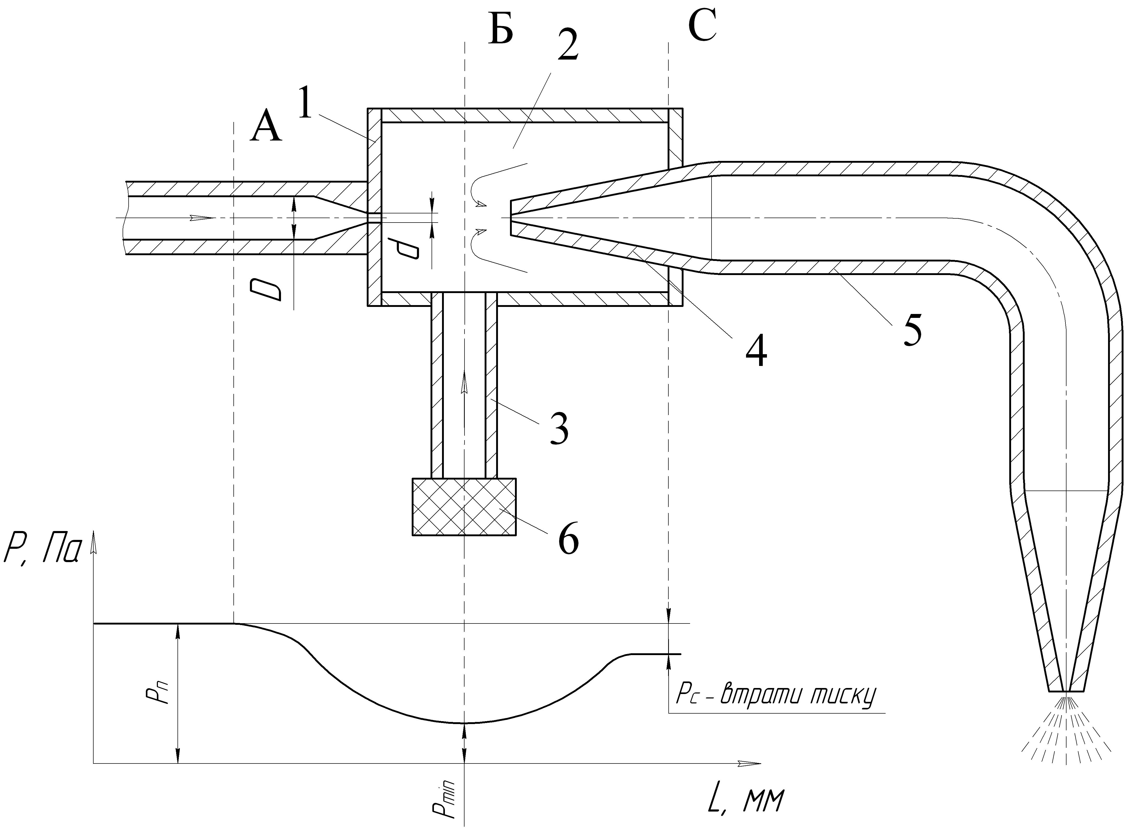
а)
б)

Figure 2. Jet pump (s) and static pressure distribution (b) along its length

The equation of conservation of constant mass flow of the working fluid at the inlet and outlet of the nozzle is:
(1)
or:
(2)
where Uп – initial velocity of the working fluid;
D – diameter of the doubled pipe;
Uc – the rate of the working fluid at the outlet of the nozzle;
d – diameter of the nozzle;
$ρ$ – density of the working fluid.
Influenced by vacuum the liquids that needs pumping out trays are absorbed from working chambers and pipe 3, are captured by the working fluid stream and mixed with it, going to diffuser 4, and then – to discharge pipe 5 at the end of which there is the spray nozzle.
Figure 3 shows a graph of the velocity of the working fluid at the outlet of the nozzle jet pump depending on the ratio of diameters of pipe and nozzle diameter. Form of empirical chart shows a different increase rate of the working fluid at the outlet of nozzle with the increase ratio D / d and increasing of Uп.
The flow of the working fluid in section A (Fig. 2) begins to narrow, resulting an average flow rate increases. Due to the inertia of the jet continues shrinking and at some distance from the nozzle has the largest narrowing. This narrowing falls on section B, which coincides with the axis of the suction pipe 3. Reduce speed on the section AB is accompanied by a decrease in pressure from the initial statistical significance Pn to a minimum – Rmin.
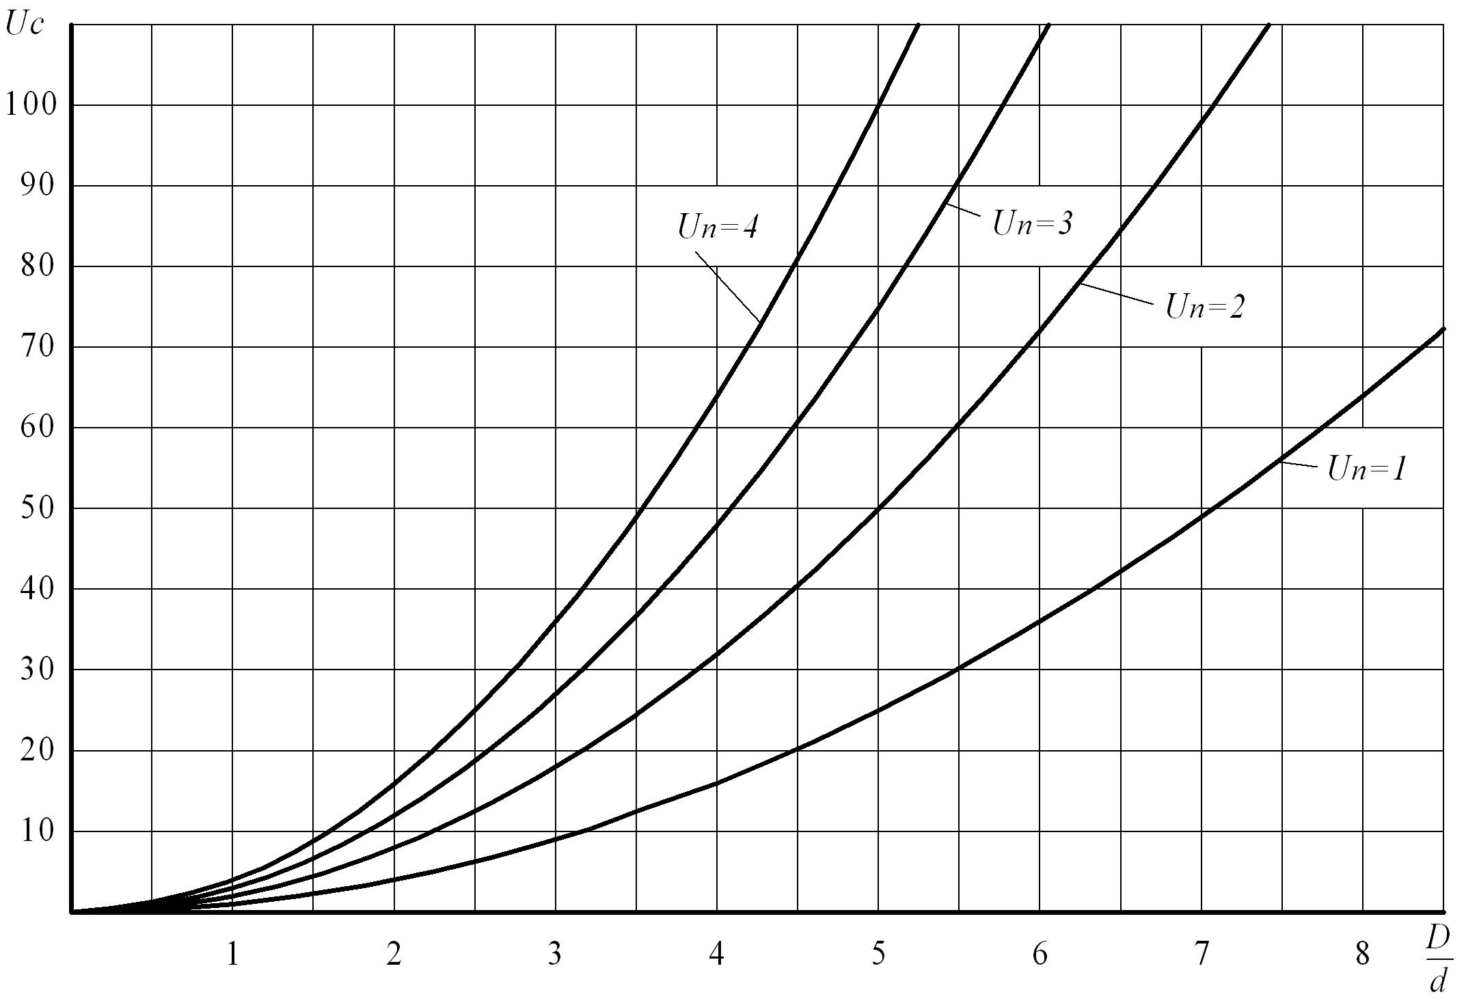
Figure. 3. Chart speed change of the working fluid at the outlet of the nozzle jet pump depending on the ratio of inlet diameter (D) and output (d) of the nozzle at different initial velocity (Uп). (; ).

Pressure difference in this section causes the formation of a vacuum in the chamber 2. This vacuum is sucking of the working fluid working chambers of the trays.
Using the well-known Bernoulli equation for the two sections A and the output section of the nozzle, we have:
(3)
where P1, P2 - pressure of the working fluid in the relevant sections,
or
(4)
After the introduction of substitutions and the relative diameters we have
(5)
Conclusions: To reduce the pesticide load on the soil during spraying of potato plants it is advisable to use the tunnel type installing with a closed system of circulation of the working fluid. Pumping of the working fluid is best done using a jet pump that has no moving parts that best affect the reliability and efficiency of the entire installation.
REFERENCES:
1. Арендаренко В.М. Використання технічних засобів при збиранні та знищені колорадського жука. Монографія / В.М. Арендаренко. – Кременчук: ПП Щербатих О.В, 2012. – 132 с.
2. Гуцол Т.Д. Обґрунтування параметрів та режимів роботи пристрою для механічного збирання комах-шкідників просапних сільськогосподарських культур: автореф. дис. … канд. техн. наук : спец. 05.05.11 «Машини і засоби механізації сільськогосподарського виробництва» /
Т.Д. Гуцул. – Львів, 2007 – 20 с.
3. А.с. 1685347 СССР, МКИА А 01 М5/08. Устройство для сбора насекомых с растений /
К. Эргашов, С.Н. Алимухамедов, Н.В. Жуйков, А.К. Кадыров, А.К. Хакимов, Ю. Болтабаев (СССР). –№449410/15 ; заявл.17.10.88 ; опубл. 23.10.91, Бюл. №39.
4. Патент на корисну модель 360034 України, А 01 М5/05. Установка для збирання та знищення колорадського жука АСЖ-1 / В.М. Арендаренко, Е.Я. Прасолов, О.П. Слинько, Р.М. Харак, С.А. Браженко, Л.В. Знова, В.А. Шенель, С.В. Гладкий, О.О. Багмен, Д.О. Швець (Україна). –№200806109 ; заявл. 12.05.08 ; опубл. 10.10.08, Бюл. № 19.

