© 2015
Gavrylenko O. S., Candidate of Veterinary Science
Ukrainian State Scientific Research Institute of Nanobiotechnologies and Resource Reservation
SUBSTANTIATION OF EXPEDIENCY OF THE SPECIFIC PREVENTION OF INFECTIOUS BRONCHITIS OF HENS
Reviewer – Candidate of Veterinary Science V. M. Mukovoz
In the publication we presented data on the specific prevention of infectious bronchitis of hens, that is based on the use of specific drugs (vaccines), as well as the fulfilling common sanitary and veterinary measures. It was determined the period of conservation transovarial antibodies in blood serum of chicks-broilers and the optimal time for chicks’ vaccination, as well as we compared the effectiveness of the vaccine, made from different strains of infectious bronchitis virus of chickens.
Key words: infectious bronchitis of hens, specific prevention, broiler-chicks, vaccine.
Statement of the problem. The industrial production of broiler meat in Ukraine is one of the most profitable branches of agriculture. From year to year poultry stock is increasing rapidly, along with the range of its crosses. The vast majority of that is delivered to Ukraine from abroad. In connection with this the question the risk of rapid spread of dangerous infectious poultry diseases arises, namely infectious bursal disease, chickens infectious bronchitis, Newcastle disease and other [2, 3].
Infectious bronchitis of hens is registered in almost all countries where poultry raised on an industrial basis. In large poultry farms of hens infectious bronchitis is characterized by stationarity and runs across the normally in the form of chronic infection, thus damaging the respiratory system of chickens [6].
The analysis of the major research and publications, which began solution of the problem. The current system of antiepizootic measures to protect poultry stock was developed by many domestic and foreign scientists [2]. Traditionally its essence consists in the implementation of complex of quarantine measures that prevent skidding primarily of infectious diseases in successful farms and conducting regular monitoring of the degree of intensity of immunity. To protect poultry complex specific preventive practices for using live and inactivated vaccines [5, 7].
The widespread of viral diseases of poultry in neighboring countries and the experience of foreign researchers determine the relevance of specific prevention [8, 9]. It is well known that the unsystematic use of vaccines is inadmissible and may result in severe unpredictable consequences. Especially dangerous is the potential threat of the spread of infectious bronchitis of hens associated with the emergence of highly virulent strains of viruses [9].
Nevertheless, methodological developments of terms and method of application of vaccine preparations it is still not substantiated. In many countries, the research work on the development of strategies to combat diseases of poultry and of vaccination schemes using modern vaccine preparations is conducted [9, 10].
Consequently, in Ukraine the system of antiepizootic measures aimed at protecting the livestock of poultry from infectious diseases requires constant improvement. The effectiveness of vaccination is largely dependent on the homogeneity of maternal immunity [1, 4].
Goals of research: substantiation of expediency of specific prevention of infectious bronchitis of chickens on broiler-chickens, the selection of vaccines with followed practice of their conditions of use.
To achieve this goal we had to decide the following objectives:
1. Define the storage period of transovarian antibodies against infectious bronchitis in chicks-broilers;
2. Determine the optimal period for vaccination of chickens against infectious bronchitis;
3. Compare the immunogenicity of vaccines from various strains of the pathogen.
Materials and methods of research. For specific prevention of infectious bronchitis of hens we used dry live vaccine strain of «N-120», live vaccine strain of «Ma-5». Also we performed associate vaccination of chickens against infectious bronchitis and Newcastle disease using a live lyophilized vaccine «IP + ND vaccine Nobilis Ma-5 + Clone 30». Vaccination was performed by large dispersed aerosol treatment. For a comprehensive vaccination of healthy chickens against a number of infectious diseases vaccine we used «Pro-Vak 4», which was injected intramuscularly at a dose of 0,5 ml. To determine the intensity of the immune blood, samples were collected in sterile test tubes, pre-moistened with saline solution. Specific activity of blood serum to virus IBH was determined by ELISA using diagnostic kits of the company KPL (USA). The level of antibodies presented the return values for ELISA titers and Haemagglutination Inhibition (HI) test in logarithms with base 2 (log₂).
The results of the studies. At the beginning of the observation period immunization against IBH in chicks-broilers was not performed. The vaccinations were subject only chickens of the parent flock at the age of 120–130 days a vaccine «Pro-Vak 4». Previously chickens were immunized by live vaccines according to plan of antiepizootic measures.
During of regular research of blood serum by ELISA we observed a gradual increase in titer of antibodies to the virus IBН and their varieties. Simultaneously with low levels of antibodies (120–210) were detected single serum samples from chicks-broilers of 40 days old with antibody titers 8000 and above. Clinical manifestations of the disease was not observed, but the postmortem autopsy of poultry have noted varying degrees damaging of the respiratory system and of kidneys .
Based on these results, it was decided to immunize broilers against the IBK. Primarily conducted vaccination of chickens aged 15 days for using a live vaccine strain of «Н-120» by watering, combining it with the vaccination against Newcastle disease. Effect of immunization against the IBН on economic performance is reflected in the table 1.
Table 1
The economic performance before and after the use of vaccines to prevent IBН in chicks-broilers
Schemes | The average mass of 1 head, g | Average daily growth | Preservation, % | Index of productivity
Before vaccination | 1595+90 | 35,3+0,9 | 83,5+0,6 | 150,3+5,3
After vaccination | 1800+70 | 37,8+0,8 | 89+1,2 | 169,3+4,1
As it is evident from table 1, all the economic indicators after the use of live vaccine strain «H-120» is improved (P<0,05). In addition, we have noted reduction of the death of chickens with signs of defeat of respiratory organs and kidneys, as well as reducing the per cent of death of chicks caused by secondary bacterial infections.
Due to the fact that despite the conducting of preventive vaccination, after some time in isolated samples of blood serum of chickens we found high titers of antibodies (till 10000), it was decided to replace the vaccine strain and amend the terms and methods of immunization. Several immunization schemes with using different vaccine strains, vaccination terms, methods of application and multiplicity were worked.
The experiments were conducted during scheduled growing crosses of Cobb broiler-500 in accordance with technological graphs. For immunization IBH following vaccines were applied: 1) live vaccine strain of IBH «Ma-5»; 2) live vaccine IBH Associate and HN «Ma Clone 5 + 30»; 3) live vaccine strain of IBH «H-120». Vaccines were applied to the following scheme (table 2).
Table 2
The scheme of preventive immunization of chicks-broilers against IBH
№ of schemes | Age of chicks during the immunization, days | Method of administration of the vaccine | The vaccine strain
1 | 16 | watering | «Н-120»
2 | 5 | aerosol method | «Н-120»
 | 15 | watering | «Н-120»
3 | 5 | aerosol method | «Н-120»
4 | 1 | aerosol method | «Н-120»
5 | 1 | aerosol method | «Ма-5»
6 | 1 | aerosol method | «Н-120»
 | 16–17 | watering | «Н-120»
7 | 1 | aerosol method | «Ма-5»
 | 16–17 | watering | «Ма-5»

Chickens were immunized by large aerosol dispersed in 1 day age in the hatchery and (or) in 5 days age directly into the room. The revaccination of chickens in 15 or 16–17 days age was performed by watering the vaccine with the addition of skimmed milk powder (5 % by volume).
For determine the effectiveness of immunization every time were selected serum from each group of 25 chickens – 1, 11, 15, 19, 29, 35 and 40-days old. The obtained serum was tested for the presence of antibodies to the virus IBH in the ELISA method for general use, and then was calculated the average values of the titer in the group. The results are shown in pictures 1 and 2.
Picture 1 shows the results of serological studies of blood serum of broiler chickens, which were immunized against the IBH once.
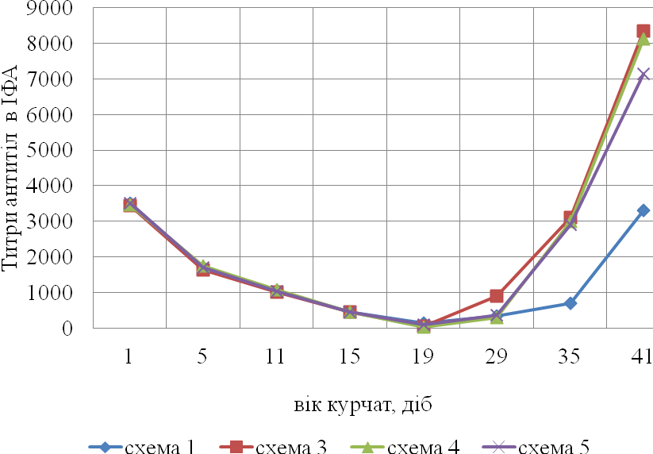
Picture 1. Dynamics of accumulation of antibodies to the virus of IBH after a single immunization of live vaccine against IBH
The data presented in picture 1 indicate that 1-day chickens before immunization showed high titers of transovarian antibodies. In chickens of 5-days of age, vaccination which was held by the scheme 3, was observed also quite high (1623+215) level of antibodies to the virus IBH. Just before application of a vaccine in chickens of 16-days of age for use by scheme 1, transovarian antibody level was relatively low – 452+26.
After a single use of vaccines in 1 or 5-days of age (scheme 3, 4 and 5) we observed a sharp decline in antibody levels, which lasted up to 19-days old, when there is a complete breakdown of maternal antibodies in these chickens groups (level of antibodies was 50+16, 32+3, 101+27 to groups, respectively). Later in chickens immunized by the scheme 3, there was a sharp increase in antibody titers to the end of growing and reached a value of 8342+1526. In chickens immunized by the schemes 4 and 5, a similar picture was observed in the dynamics titers of specific antibodies – initially gradual reduction of antibodies to the 29-days old with subsequent a sharp increase to 41-days old to 8125+569 and 7136+253 respectively. The coefficient of variation in antibody titers after the application of these schemes was within 25–27 %. In chickens immunized at 16-days of age, the increase in antibody titers has been slow, and the end of the growing value reached the level of 3310+225.
Picture 2 reflects the results of serological studies of blood serum of broiler chickens, which immunized against IBH performed twice: scheme 2 – the first time on the fifth day and revaccination 15th day of chickens’ growth, scheme 6 and 7 – the first immunization of 1-day old and revaccination 16–17-day old chicks.
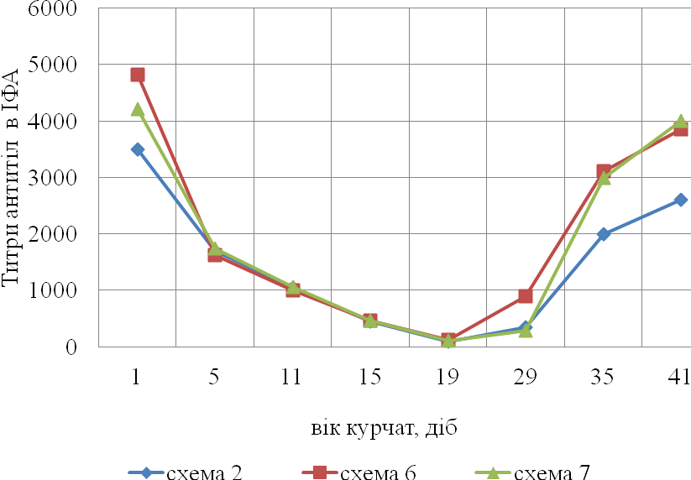
Picture 1. Dynamics of accumulation of antibodies to the virus of IBH after a double immunization by live vaccine against IBH
In analyzing the data, that displayed in picture 2, there are similar changes in the graphs of antibodies to the virus IBH in chickens immunized by the schemes 6 and 7, in both cases, before the first vaccination were observed high titers of antibodies to the virus IBH (4826+235 and 4215+198 respectively). Before reimmunization in 16–17-days old antibody titer values fell to 117+12 in chickens vaccinated by the scheme 6 and fell to 108+25 by the scheme 7. Until the end of cultivation in the study of blood serum we detected high level of antibodies which amounted to 3847+135 and 3996+265.
In conducting immunization by the scheme 2, it was found that the titer of antibodies to the virus IBH by the end of the observation period was lower than on poultry vaccination by the scheme 6 and 7 (P<0,05). The biggest difference in antibody titers was noted in the study of blood serum of chickens 41-days old (scheme 2 – 2605+125, the scheme 6 – 3847+226 and the scheme 7 – 3996+125) (P<0,05). The coefficient of variation in the application of these schemes was within 12–15 %.
The level of antibodies after the vaccine strain of «H-120» and the vaccine strain of «Ma-5» has differed little (P<0,05).
As a result of one-time vaccination of 1-day old chickens level of antibodies to the virus IBH to 41 days of growth was high and equal to 8125+569 and 7136+253 respectively, and after a double application totaled 3847+226 and 3996+125 respectively (P<0,05).
Conclusions:
1. By experimental way on chicks-broilers obtained from hens vaccinated against the IBH is shown that the transovarial antibodies against indicated infectious disease are saved in a high titers in the first 10–17 days that are sufficient to protect against disease and then level of antibody titers reduced and not provides protection against infection.
2. We established that it is expedient to vaccinate chickens at the age of 16–17 days against the IВН, because in this period there is active production of antiviral antibodies.
3. In the comparative experiments it is shown that on the two-time immunization of chicks-broilers in the first day and then 16–17 days of age of the vaccine strain «H-120» or a vaccine strain of «Ma-5» post-accumulation level of antibodies in the serum blood of chicks is alike high and provides reliable protection from infestation by a virus of IBH.
BIBLIOGRAPHY
1. Aнтонов Б. И. Использовaниe мeтодa ПЦP пpи диaгностикe остpых инфeкционных болeзнeй животных / Б. И. Aнтонов // Вeтepинapный консультaнт. – 2002. – №16–17. – С. 22.
2. Болотников И. А. Иммунопрофилактика инфекционных болезней птиц / И. А. Болотников. – М. : Россельхозиздат, 1982. – 183 с.
3. Свиноус І. В. Економічні проблеми розвитку птахівництва України / І. В. Свиноус, О. Ф. Кирилюк // Сучасне птахівництво. – 2009. – № 6–7. – С. 3–8.
4. Стан і перспективи розвитку галузі птахівництва України // Ефективне птахівництво. – 2006. – №10. – С. 11–14.
5. Рябоконь Ю. О. Наукове забезпечення галузі птахівництва / Ю. О. Рябоконь // Вісник аграрної науки. – 2006. – №3–4. – С. 124–126.
6. Диагностика, профилактика и лечение инфекционных заболеваний птиц / Торговый Дом «Биопром». – М., 2001. – 64 с.
7. Вакцинопрофилактика инфекционных болезней птиц / Торговый Дом «Биопром». – К., 2005. – 55 с.
8. Сравнительная оценка живых вакцин против инфекционного бронхита кур / [Голод Я. Р., Кожемяка Н. В., Терюханов А. Б и др.] // Ветеринария. – 1990. – №11. – С. 12–14.
9. Yoshimura S. The situation and the precaution of infectious bronchitis / S. Yoshimura // Niwa-tori-No-Kenkyu, 2012. – Vol. 63. – №12. – P. 65–71.
10. Villegares P. Avian virus diseases. Laboratory Manual / P. Villegares // College of Vet. Med. – Athens, Georgia, 2012. – P. 89.

