УДК 004:378.14
© 2014

Opara N. M., Candidate of agricultural sciences
Poltava State Agrarian Academy

INFORMATIONAL TECHNOLOGIES IN THE PROCESS OF TEACHING ANDSTUDYING SAFETY OF VITAL ACTIVITIES AT HIGHER SCHOOL
Reviewer – Candidate of technical sciences S. P. Shkoliar

Informational technologies in the process of teaching the course Safety of vital activities at higher educational establishments are considered in the article. Detailed attention has been paid to using general approaches, suggested by a group of authors, the leading components of conceptual apparatus, on the basis of which it is possible to improve the contents, forms and methods of study process shave been discussed. In the process of.quickly increasing informational loading the quality of study process greatly depends on its intensification and optimization on the basis of effective using classical and also active introducing new methods which are based on the broadest using of computers of various modifications.
Key words: informational technologies, safety of vital activities, conceptual apparatus.
Statement of problem Modern development of society is characterized by quick informational chances in all fields of human activities. Computer technologies have gone closely into everyday life, which makes the society recognize their necessity and use in all the spheres of human life and activities. Taking into account reforming the system of education concerning the introduction of computer technologies, in 1998 the Law of Ukraine was adopted ”About the national program of computerization “, which became the basis for the beginning of general computerizing of education in Ukraine. On the grounds of it using computers has to be aimed at improving the contents, forms and methods of study process.
Modern power creation processes in our country have increased the necessity of reforming the system of education, the main measures of which are defined by the Law of Ukraine “About education”, the Decree of the President of Ukraine “About the main directions of reforming higher education in Ukraine”, the national program “Education”, other legislative documents of the Ministry of education and science of Ukraine..
The analysis of the main investigations and publications, in which solving of the problem has been initiated. The same terms and concepts are not similarly explained in scientific works of researchers engaged in problems of computerizing education and society on the whole (A. Yershov, I. Robert, Yu. Leshbits, S. Peilert) Let us make an attempt to specify the conceptual apparatus of new informational study technologies, using the general approach suggested by M. Zheldak and T. Tykhonova [2]:
- computer-programming means (CPM), which automatize partially or completely the process of studying and knowledge control are the study systems, program simulators , systems of testing and control, systems of imitational modeling, demonstration systems;
- programming and pedagogical means (PPM) is the sum total of computer programs of study significance;
- imitation-modeling program (IMP) is the study computer program which enables to observe and model processes, phenomena or objects on monitor screen;
- virtual reality (VR) is a highly developed form of computer modeling, which enables user to get deeper into modeled world and directly enter it. Visual, auditory, tactile and motive senses in this case are substituted by their imitation with the help of computer programs;
- multi-media computer is the computer, provided with apparatus and programming means due to which multi-media technology is implemented;
- multi-media is a generalized notion for different computer technologies and use of several informational environments (graphs, text, video, photographs, animation, sound effects);
- means of new informational study technologies (MNIST) are modern means of studying and systems of informational accounting, and also study and methodological, normative-technical and organizational-instructive materials, with the help of which operations of accumulating, analyzing, systematizing, storing, transmitting and giving information are performed; also the materials that provide pedagogically relevant use of these operations;
- new informational study technologies (NIST) are methodology and technology of studying and educational process with the use of computers and the latest electronic means of studying;
- new informational technologies (NIT) are the

Components of new informational technologies
New informational technologies (NIT)
Means of new informational technologies
Apparatus | Programming | Methods of NIT
Electronic computing machine, personal electronic computing machine, local and global networks, devices of introducing-withdrawing, means of storing large volumes of information and other modern peripheral equipment | Programming complexes, informational systems, systems of scale graphics, multi-media and hyper-media systems, systems of artificial intellect, means of programming inter-computer communication | System analysis, system designing, means of transmitting, storing and protecting information, non-paper technologies, methods of collective using informational resources

sum total of methods and technical means for accumulating, analyzing, storing, transmitting and providing information with the help of computers and computer networks (see the table).
The aim, task and methods of performing research. The aim is to reveal the essence of existing informational technologies in the process of teaching Safety of vital activities at higher educational establishment. The main task is to make detailed task of general informational education on modern stage in Ukraine.
The results of research. As the results of research show, the use of any means of studying, and, first of all, of computers considerably increases the possibilities of sense organs and mental faculties of students concerning perception, comprehension and memorizing information It is the result of students’ memorizing peculiarities concerning the necessary information depending on the kind and the number of analyzers, participating in the process of cognition [3].
Human sense organs have different abilities as far as the perception and memorizing of information is concerned.
As the capacity of visual complex of information perception is much higher, than the capacity of auditory channel (approximately 7.5 times), the most effective information perception is provided by optimal combination of verbal and visual form of its presentation, which takes place at the lessons with complex informational impact [5].
As it can be seen from the diagrams, the main channels of information perception in study process are visual and auditory. The information, presented in the visual form, is much more productive [4].

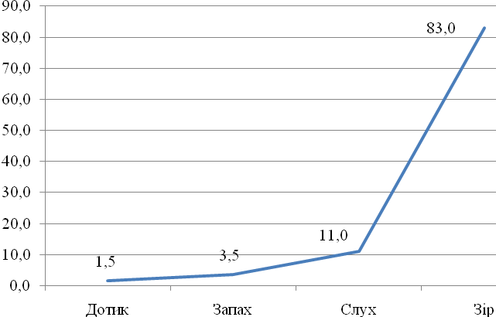
Touch
Smell
Hearing
Eyesight
Fig. 1. Comparative characteristics of human sense organs
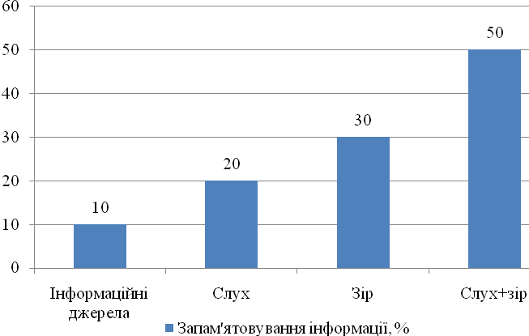
Informational sources
Hearing
Eyesight
Hearing+ Eyesight

Memorizing information
Fig. 2. The advantages of combining verbal and visual
forms of providing information as compared with the singled out ones

Conclusions: 1. In the conditions of quickly growing informational loading the quality of study process greatly depends on its intensification and optimization on the basis of effective use of classical and also introduction of new methods, which are based on the broadest use of computers of various modifications.
2. At the present stage of introducing computers into the study process at higher educational establishments, they are used not only as a powerful means of storing considerable volume of information in different branches of knowledge, but also in uniting with the latest study technologies, [3] and new methods and means of studying; methods and means of managing study and educational process. On the whole, mastering work with computers by teachers at higher educational institutions is taking place slowly, which is connected not only with the lack of financing of educational institutions, but with passive attitude of considerable number of teachers to technical re-equipment of higher schools and the necessity to improve the traditional study system for training students with the aim of their full value vital activities in the conditions of society computerization..

REFERENCES

1. Величко С. П., Царенко І. Л., Царенко О. М. Методика викладання безпеки життєдіяльності: навчальний посібник. – К. : Хіт, 2008. – 318 с.
2. Жалдак М. И. Система підготовки учителя к использованию информационных технологий в учебном процессе. – М., 1988. – 48 с.
3. Логико-психологические основы использования компьютерных учебных средств в процессе обучения // Информатика и образование. – 1988. – № 3. – С. 5–12.
4. Методика навчання і наукових досліджень у вищій школі: навч. посіб. / С. У. Гончаренко,
П. М. Олійник, В. К. Федорченко [та ін..]; за ред. С. У. Гончаренка, П. М. Олійника. – К. : Вища школа, 2003. – 323 с.
5. Освітні технології: навчально-методичний посібник / О. М. Пєхота, А. З. Кіктенко, О. М. Любарюк [та ін.]; за ред. О. М. Пєхоти. – К. : А.С.К. – 2003. – 255 c.

